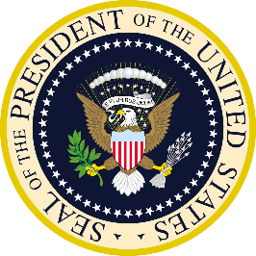
Executive Branch
Chapter 9: The Presidency
- Sources of Presidential Powers
- Constitutional Powers
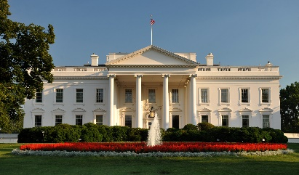
- Need for a Strong Executive
- The Framers of the ________________did not want the leader of our country to become a tyrant
- The Framers knew that a strong executive was needed to _____ out the acts of Congress
- The Framers also wanted a strong executive because the ______________ direct participation by the people in decision making.
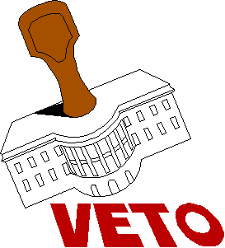
- Powers Defined in the Constitution
- Article II of the ________________ gives lays out the power of the President
- Defined Powers include:
- ____________ laws
- Veto legislation
- Command the ___________
- Engage with foreign leaders
- With Senate approval the President can:
- Make __________ with foreign nations
- Appoint ambassadors & federal judges
- Growth of Presidential Power
- Inherent Powers
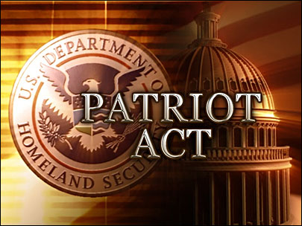
- Inherent powers are the reason for which Presidents have justified ____________ their powers
- ___________Powers- are those claimed by the president that are not clearly expressed in the Constitution
- Presidents say they have these powers because of _________ worded phrases in the Constitution
- “The executive power shall be vested in a President”
- They also claim inherent powers is part of the ________________ job.
- When Presidents exercise these powers, Congress and the courts may either try to ________the power or go along with it
- Immediate Needs of the Nation
- Presidents often have to use inherent powers during _____ or other times of ________________
- Examples throughout history
- President Lincoln suspended the writ of habeas corpus
- President FDR had to use inherent powers to help get the country out of the Great Depression
- President George W. Bush, declared “war on terrorism” and expanded the power of the President to combat terrorism
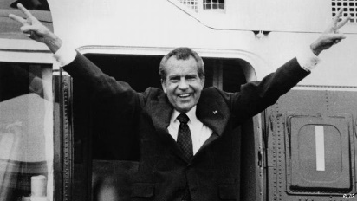
- Executive Privilege
- This power is not _______ in the Constitution
- This is the right to ___________from Congress or the courts information about ________________ between the _______________and his or her advisers
- The Supreme Court ruled that ______________ privilege only applies with certain qualifications, but is still a part of _____________of Power
- Popular Opinion
- All Presidents like to _______that their ideas and polices represent a mandate from the people
- ___________can be an informal source of presidential power, but popularity ratings can change quickly
- Modern day Presidents use ________ media as a way to sway public opinion
- _________opinion can also limit eh President because without favorable public opinion it can be hard for Presidents to enact a political program
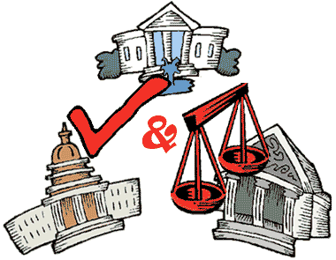
- Checks and Balances on Presidential Powers
- The ___________ built significant safeguards into the Constitution against the possibility that the President would abuse their lawful powers
- The __________ Court can rule executive actions unconstitutional
- Congress can pass __________ even if a president vetoes the law
- The Senate must __________ a president’s appointees and all treaties
- The _________ & _________ can also impeach the president
- Presidential Roles
- Head of State- the president serves as a ceremonial figure representing the United States
- Chief Executive-the president lead the executive branch of government, which implements the laws that Congress passes, and appoints federal judges and heads of executive departments and agencies
- Commander in Chief-the president is responsible for the nation’s security and is in charge of the military
- Chief Diplomat-the president meets with foreign leaders, appoints ambassadors, and makes treaties
- Legislative Leader-the president delivers an annual State of Union message to Congress, proposes legislation, sign or vetoes laws, and can call Congress into special session when necessary
- Economic Planner- the president appoints economic advisors, meets with business leaders, prepares an annual budget request, and submits economic reports to Congress
- Party Leader- the president leads his or her own political party, rewarding party supporters with positions in government, and helps to elect other party members by raising money and campaigning for party members
- Head of State & Chief Executive
- Head of State
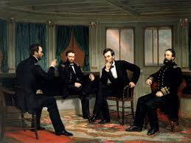
- The president, as head of state, represents the ________ and performs many ceremonial roles
- Some of the _______ as head of state are mentioned in Article II of the Constitution
- Modern presidents play an _____________ role as a leader when a natural disaster strikes, especially to give words of comfort
- Some _______ that are less serious include:
- Throw out the first pitch to begin the baseball season
- Light the nation’s Christmas tree and Menorah
- Meet public figures
- To millions around the world the president is the _________ of the United States
- Chief Executive
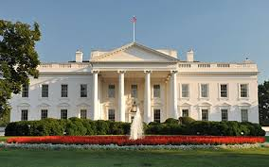
- The _____________ is the leader of the executive branch of government and carries out laws that Congress passes
- There are more than _____ departments and agencies that follow under the jurisdiction of the President
- More than ____ million people work for the Federal government
- The President’s executive power is described in the Constitution, but the _____________ does not provide much detail about the components of this power
- The Constitution states the _____________ shall have powers & that “he shall take Care that the Laws be faithfully executed” (Articled II Section 3)
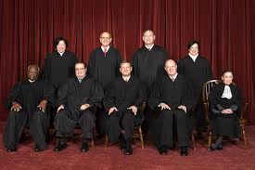
- The Appointment Power
- The ____________ appoints about 2,200 top level federal officials who run the executive branch
- The authority to __________ officials is the most important tool a president has to influence legislation
- Presidents try to appoint _________ that share their political beliefs
- Presidents can also control the _________________ of laws by firing officials they have appointed
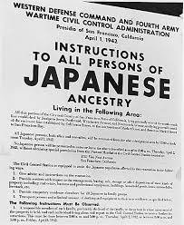
- The President also appoints all _________ judges, include the justices of the ___________ Court
- Executive Orders
- Executive orders are _______________ directives that have the force of law without the approval of Congress
- This is an __________ power of the Constitution
- Executive orders maybe issued to detail _________ actions federal agencies must make to implement a law
- They have also been used to make ___________ new policy
- Even though Presidents can use the executive order their ___________ may just as easily reverse them.
- Impoundment of Funds
- Happens when the ____________ has a deep disagreement with _____________ on what programs should exist
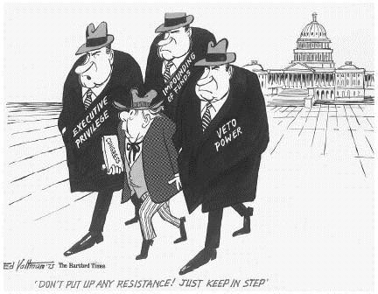
- Impoundment of Funds means that the President ________ to spend funds Congress approved to carry out the programs they are disagreeing about.
- _____________ of impoundment argue that it is an inherent power of the executive
- _____________ argue that impoundments undermine the will of the people who have chosen the legislators who created and funded the programs
- Reprieves, Pardons, and Amnesty
- A ____________ postpones legal punishment
- ___________ releases a person from legal punish, usually people who have been convicted of a federal crime
- ___________ is a pardon for a group of people who have committed an offense against the government
- Commander in Chief/Chief Diplomat
- Commander in Chief
- Power to Make War
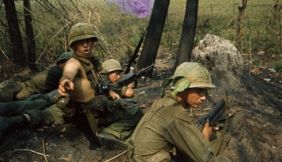
- ____________ retains the power to declare war, and to fund the military
- Presidents have sent American forces into action many times without ______________ of war
- _____________________ (1973) does limit the power of the president to wage war without a formal declaration
- Prevents presidents from committing troops to combat for more than 60 days without Congress’s approval
- Allows Congress to order the president to disengage troops involved in an undeclared war
- Since the War Powers Act there have been many instances where the ____________ has engaged in military operations
- Military Operations and Strategy
- ________________ are responsible for key military decisions that define military policy and strategy
- The president is a ____________, and not an active member of the military, and thus may not have any military experience
- The president will ____________ regular reports from the military and national security leaders that help him or her know about ____________security threats
- Shadow War
  - In the last ___ years, the US has conducted shadow war
  - Shadow Warfare is fought in secret by __________ operations troops, hired contractors and armed drones
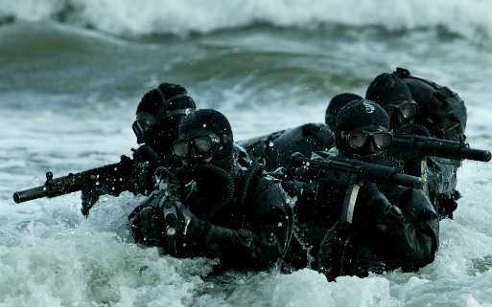
  - Many shadow war ______________ are classified (information not made public)
  - There are groups out there who want to try to make the information about special activities public, so that the _________ can hold the government accountable.
- The Presidency in Times of War
- During a war, the ______________ often claims powers to protect the nation
- Congress is also more likely to give the president special ________ at home and abroad
- Examples:
- FDR during WWII was given the power by Congress to control prices, ration gas and food, and manage the industries needed to produce military weapons
- President George W. Bush after 9/11 expanded presidential powers as a way to fight terrorism & a few weeks after the attacks Congress passed the US Patriot Act
- Chief Diplomat
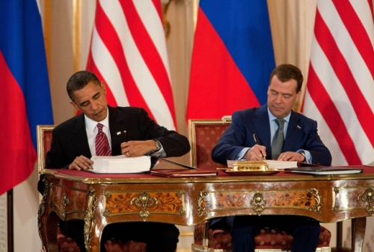
- Treaties and Diplomatic Resolutions
- Under the ___________________ the President has the sole power to negotiate and sign treaties, but Congress has to approve it
- The Senate takes its powers to __________ treaties very seriously, sometimes Congress can even restrict or deny funds to __________ policy initiatives
- In the struggle over foreign policy the President has two advantages over Congress:
- _______________________________
- _______________________________
- Executive Agreements
- These are pacts between the ______________ and the head of a foreign government
- They have the same ________ status as treaties, but do not require Senate consent
- They involve routine matters, but could include more __________ arrangements
- Some presidents have tried to keep these agreements but Congress passed a law in _________ requiring the president to make public all executive agreements
- Recognition of Foreign Governments
  - The president decides whether the United States will ___________ government of other countries
  - Presidents determine whether the government will acknowledge the _______ status of another country
  - Presidents sometimes use _____________ as a foreign tool
- Legislative, Economic, and Party Leader
- Influencing Legislation
- Tools to Influence Congress
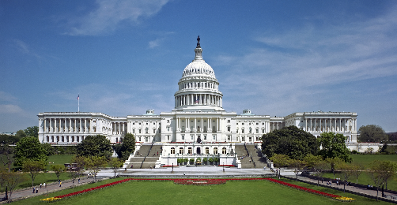
- The president works to ________________ Congress in several ways
- If the Congress has a ___________ in Congress from the party, then several of the president’s laws will get passed
- A standard measure of presidential success with Congress is how frequently presidents get their way on congressional roll call votes
- When Presidents and the _____________ of Congress are from different political parties the president must work harder to influence ______________ to support his goals
- Presidents may do the following to influence Congress:
- Hand out political favors
- Visit the home state of a member of Congress
- Start a federal project that will bring money and jobs to a member’s home state or district
- The Veto
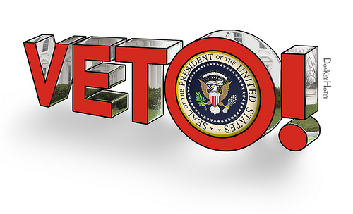
- This is a very important _______ in lawmaking
- The president has ____ days to veto or sign the law or it automatically becomes a law
- ____________ veto: is where Congress adjourns before the 10-day period and thus a bill does not become a law
- Presidents sometimes use the ___________ of veto to force Congress to stop a bill or change it
- The president does not have the power to veto selected _________ in the bill (governors have this power)
- Congress did attempt to give the president more power for line item vetoes in _________, but the Supreme Court in Clinton v. City of New York found the law unconstitutional
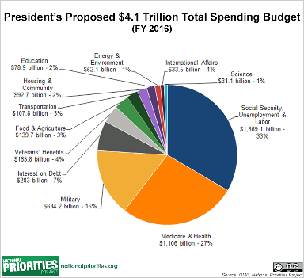
- Economic Planning
- The president’s role as ________ economic planner was not set out in the Constitution but it developed over time
- One of the ____________ duties of the president is to prepare an annual budget
- Presidents work with _______ officials to decide what government programs to support or programs to cut back
- Decisions on budgeting reflect the presidents _____________
- The annual budget proposal is ____________ to the House, where it is modified and debated
- Ultimately, Congress passes a law that creates the budge and the ______________ can sign or veto the law
- Political Party Leader
- The _____________ political party expects the chief executive to be the party leader
- The president may give ___________ to help party members who are running for office
- The president also selects the party’s __________chair and often helps plan future election strategies
- Presidents are also expected to _______ members of their party to government jobs

