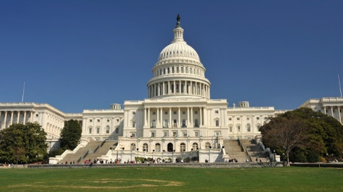
The Legislative Branch
Chapter 8: State and Local Legislatures
- State Legislatures
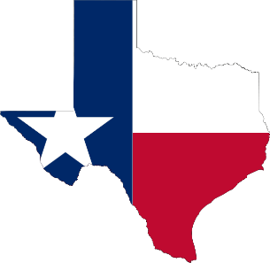
- State Legislatures
- ___________________- are lawmakers that are voted in by the citizens in order to pass laws on their behalf.
- ______________ legislature: States whom legislatures are divided into two houses.
- House of Representatives (larger of the two)
- Senate (smaller of the two)
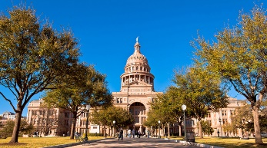
- _______________ legislature: Is a one-house legislature
- Only Nebraska, called the Senate.
- Organization of State Legislatures
- State legislatures vary greatly in _____.
- Largest: New Hampshire, 400 Representatives and 24 Senators.
- Smallest: Alaska, 40 Representatives and 20 Senators.
- These ______ legislatures are organized to represent all citizens of the ______ equally.
- Therefore, each state is divided into districts.
- Reynolds v. Sims, ruled that state legislative districts must be equal in population.
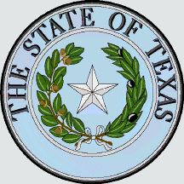
- Sessions and Leaders
- This process is similar to that of ___________.
- Most state _______________ meet in regular sessions every year, some every _____ years.
- In most states the ______________ governor presides over the state Senate.
- In the House of Representatives, they often elect their leader, called the _____________.
- The leader of each house appoints its __________________ members.
- Qualifications and Terms
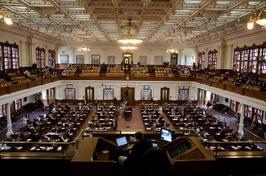
- The qualifications and terms of state legislatures vary from ______ to state.
- Most require that they be U.S. _______________.
- In almost all states you must live in the ____________ you are representing.
- Generally speaking you must be ___ years old to be a Senator and 21 to be a Representative.
- In most states Senators serve ______ year terms and Representatives serve two year terms.
- _____________ vary by state, EX. In Rhode Island they make $10,000 per year and in New York $79,500.
- State Legislative Elections
- Primary Elections
- All state senators and _________________are directly elected by the people in their voting districts
- _________states the process of election looks similar to the congressional elections but on a smaller scale
- ___________________typically take part in elections to be put on the general election ballot
- Some states require a two-part process consisting of a closed or semi-closed primary which only voters registered of a certain party can choose candidates from their party
- Other states any voter can vote on either party’s candidates
- Campaign Finance
- Some candidates for state legislatures ________ millions of dollars trying to get elected, others very little
- The __________ of money spent on a state election depends on the political importance of the district in question and the party affiliations of its voters
- Some state legislative elections attract quite a bit of national attention (example: when a state prepares to redraw districts)

- Local Governments
- Civic Participation in Local Government
- The ___________have more power at the local level than any other level
- Participating in ________ government is easier than it is at other levels of government simply because of proximity
- At the ________ level the elected officials do not wait for the citizens to come to they often go to the people
- Many ___________ and private groups make it their mission to educate people about how to be informed, engaged, and involved in local government
- Government Structure and Lawmaking
- _____________-are normally the largest territorial and political subdivision within the state
- _________-can be called municipality, they have a certain size population and geographic area
- __________________-exist as units of local government in 20 states, services vary state to state, historically they were governed with very direct participation of their residents
- ______________________-are designed to be able to better respond to specific problems, they are units of local government that deal with a specific function
- ______________________-are usually governed by an elected local body (school board), and they determine the budget for the school system and decide on new school programs and facilities

- State and Local Legislative Policy
- Public Policy Concerns of State Legislatures
- Many states have ________ to add more stringent requirements to voting
- Example: Laws to prevent voter fraud
- There are opponents to these laws arguing that it impacts certain groups of people
- Some states who have initiated voter ID have been blocked by the federal government
- States are attempting to ____________ their energy needs to protect the environment by regulating the use of energy sources
- Some states governments are in charge of ensuring that schools and education programs are providing the best outcomes for students
- Example: passing laws to allow public charter schools to not follow state laws
- Looking for ways to assess and evaluate teacher quality
- Finding ways to fund higher education
- Legislatures often ________ laws in responds to trends in crime
- Public Policy Concerns in local legislatures
- One of the goals of local governments is to create __________ cites, and so they must regulate land use by passing zoning ordinances
- Both ______ and local governments address transportation issues by providing mass transit systems
- ______________develop is handled by both the state and local government as it is their number one concern
- Smaller cities have to find away ways to promote business to compete with larger cities
- Many states and cities offer incentives to get investments into their economy
- They also pass policies that will help the workers of their state and cities

