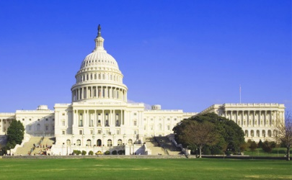
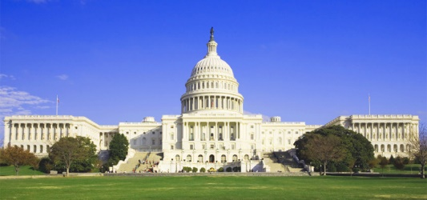
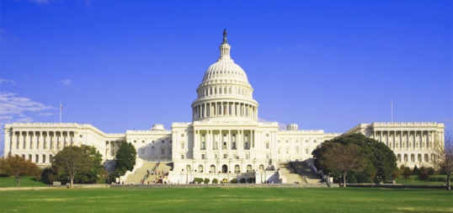
The Legislative Branch
Chapter 7: Congress at Work
- How a Bill Becomes a Law
- Type of Bills and Resolutions
  - Bill-___________________________________________________
  - Join Resolution-______________________________________________________
  - Concurrent Resolution-______________________________________________________
  - Resolution-_______________________________________________________
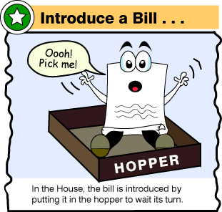
- How a Bill Becomes a Law-The House
- A _____ is a proposed law presented to the House or Senate for consideration.
- A bill or resolution usually deals with a single matter, but sometimes a ______ dealing with an unrelated matter is included.
- The clerk of the House numbers each bill, gives it a short title, and enters it into the House Journal and the Congressional Record for the day. With these actions the bill has received its first reading.
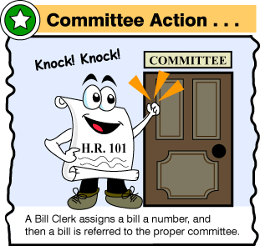
- The Bill in Committee
- If a committee pigeonholes a bill that a majority of the House wishes to consider, it can be brought out of committee via a ____________________.
- Most committees do their work through several _____________________— divisions of existing committees formed to address specific issues.
- Committees and subcommittees often hold public hearings or make a junket (trip) to gather information relating to a measure.
- Committee Action
- When a __________________ has completed its work on a bill, it returns to the full committee. The full committee may do one of several things:
  - Report the bill favorably, with a “do pass” recommendation.
  - Refuse to report the bill.
  - Report the bill in amended form.
  - Report the bill with unfavorable recommendation.
  - Report a committee bill.
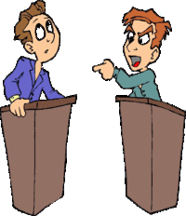
- Scheduling a Debate
- A bill is placed into one of ______ calendars before going to the floor for consideration:
- The Calendar of the Committee of the Whole House on the State of the Union
- The House Calendar
- The Calendar of the Committee of the Whole House
- The Consent Calendar
- The Discharge Calendar
- Before most measures can be taken from a _____________, the Rules Committee must approve that step and set a time for its ___________________ on the floor.
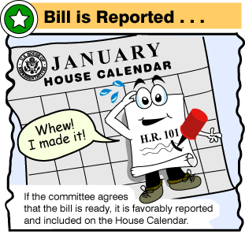
- The Bill on the Floor
- The ___________________________ includes all members of the House, however, they sit as one large committee and not as the House itself.
- When the Committee of the Whole resolves itself, the Speaker steps down and another member presides. General debate follows.
- Severe limits are placed on floor debate due to the ________ large size.
- Majority and minority floor leaders generally decide in advance how they will ______ the time to be spent on a bill
- Voting on the Bill
- There are _____ methods of taking a floor vote in the House:
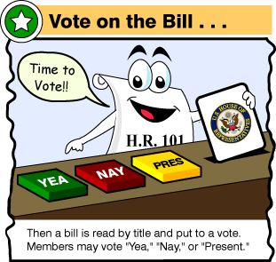
  - During voice votes the Speaker calls for the “ayes” and then the “noes.”
  - In a standing vote, members in favor of for and then those opposed to the bill rise and then are counted by the clerk.
  - One fifth of a quorum can demand a teller vote, in which the Speaker names two tellers, for and against, and members pass by each one to be counted
  - A roll-call vote may be demanded by one fifth of the members present.
- Once a bill has been approved at second reading, it is _____________, or printed in its final form. It is then read for a third time and a final vote is taken.
- How a Bill Becomes a Law-The Senate
  - Introducing the Bill
- Bills are ______________ by senators, who are formally recognized for that purpose.
- Proceedings are much less __________in the Senate compared to the House.
- The major differences between House and Senate rules regard __________ over measures.
- As a general matter, _____________ may speak on the floor for as long as they wish.
- This freedom of debate allows for the ________ possible discussion of matters on the floor.
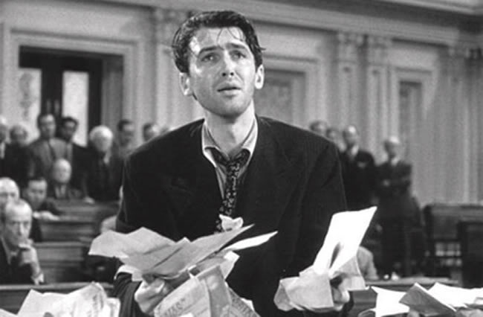
  - Filibuster and Cloture
- A ______________ is an attempt to “talk a bill to death.”
- A senator may exercise his or her right of holding the floor as long as necessary, and in essence talk until a measure is dropped.
- Rule XXII in the Standing Rules of the Senate deals with cloture, or limiting debate
- If at least 60 senators vote for ___________, no more than another 30 hours may be spent on debate, forcing a vote on a bill.
  - Conference Committee
- Any measure enacted by _____________ must have been passed by both houses in identical form.
- If one of the houses will not accept the other’s version of a bill, a _________________ committee is formed to iron out the differences.
- Once a conference committee _____________ work on a bill, it is returned to both houses for final approval. It must be accepted or rejected without amendment.
- The Final Step
- The Constitution provides four options for the President when he receives a bill:
  - The President may sign the bill, and it then becomes law.
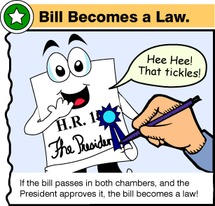
  - The President may veto the bill, or refuse to sign it. The President’s veto can be overridden by a two-thirds vote of the members present in each house.
  - If the President does not act upon a bill within 10 days of receiving it, it becomes law.
  - A pocket veto occurs if Congress adjourns within 10 days of submitting a bill and the President does not sign it. The bill then dies.

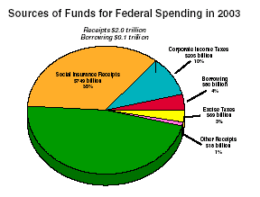
- Taxing and Spending Bills
- What is the role of Congress regarding taxes?
- Taxes as % of _______ are LOW!
- US=30%
- UK=34%
- France=44%
- Sweden=50%
- All revenue bills must start in _________
- House Ways & Means Committee
- Senate Finance Committee
- All tax bills are debated under a ____________ , which forbids members from offering any amendments to a bill from the floor
- What is the role of Congress regarding taxes?
- Under the __________________the Senate has the authority to amend tax bills passed by the House.
- To many people they view the _________as the place where special interest groups are able to get tax provisions they oppose taken out of a House bill
- In the Senate, no _________ rule exists, and tax bill often do become collections of amendments
- Most of the ________________ deal with particular interests in members’ states.
C. What is the role of Cong. regarding spending money?
- U.S. spends over $2 trill/yr. (debt v. deficit)
- Congress appropriates—approves—government spending
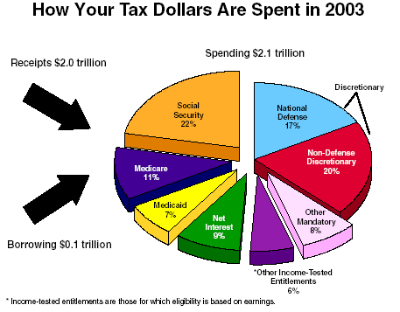
- Authorization vs. Appropriation
- ____________________-specific departments ask to receive money from Congress
- ______________________-Congress sets up federal programs and specifies how much money can be used
- President submits a budget proposal
- H & S __________________________Committees
- Hear testimony on value of gov. programs
- Uncontrollables vs. Discretionary (2:1)
- Entitlements: SS, Medicare, Medicaid, etc.

- Influencing Congress
- How do voters influence Congress?
- _________________: people one is elected to serve
- Needs of constituents vs. personal beliefs
- Daily life=constituents, Other=personal
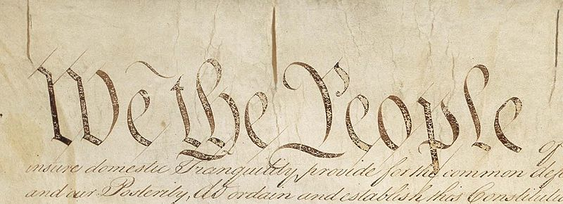
- Taking the ________:
- Visits home
- Letters/Calls/Emails/Visits
- Polls
- Big supporters’ wish lists
- _________ can be manipulated!
- Opponents enlighten, incumbents do the same
- How do political parties influence Congress?
- The more important the issue to the ________, the more partisan the vote
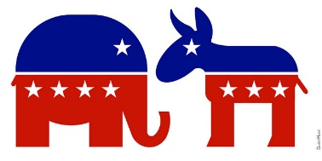
- Some issues aren’t clearly __________ by parties
- __________ do mean something:
- R: less spending, local solutions, business and $$
- D: social-welfare, tax help for ¢, regulate business
- Sometimes Congress can be ______________!
- Vote with respected colleagues
- Vote how the people with big sticks tell you to
- What are the other influences on Congress?
- __________________
- Proposals, media pressure, favors/punish
- ___________________
- Lobbyists, info, citizen action, testimony, $
- Political ________ Committees (PACs)
- Political fundraising organizations
- Personality
- Nature of issue (personal vs. people)
- Congressional staff

- Helping Constituents
- How do lawmakers help individual constituents?
- ________________: helping people w/problems
- Caseworkers handle small problems
- Lawmakers handle big problems
- Why ___________?
- Votes, oversight, it’s the nice thing to do
- Helping the ________ back home
- Pork-barrel: bring home the (bacon) public works
- logrolling
- Federal grants/contracts: get a return on tax $
- Military contracts, federal projects, etc.

