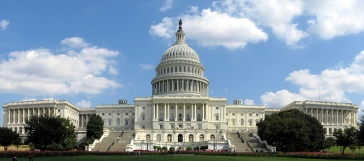
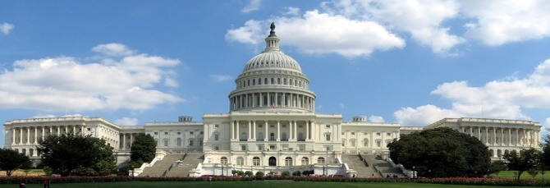
Legislative Branch
Chapter 6: Congressional Powers
- Constitutional Powers
- Constitutional Provisions
- The Constitution grants Congress a number of specific powers in three different ways:
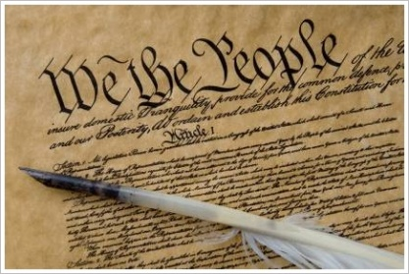
- The _________________ are granted to Congress explicitly in the Constitution.
- The _______________ are granted by reasonable deduction from the expressed powers.
- The _________________ are granted through the Constitution’s creation of a National Government for the United States.
- Legislative Powers
- A tax is a charge levied by government on persons or property to meet public needs.
- The Constitution places four limits on Congress’s power to tax:
  - ___________ may tax only for public purposes, not for private benefit.
  - Congress may not tax __________.
  - Direct taxes must be apportioned among the _______, according to their populations
  - _________ taxes must be levied at a uniform rate in all parts of the country
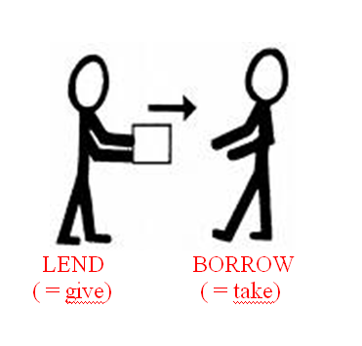
- Borrowing Money
- Article I, Section __, Clause 2 gives Congress the power “[t]o borrow Money on the credit of the United States.”
- _________________ is the practice of spending more money than received in revenue and borrowing to make up the difference.
- The ____________ is all of the money borrowed by the government over the years and not yet repaid, plus the accumulated interest on that money.
- Currency Power
- Article I, Section 8, Clause 5 gives Congress the power “[t]o coin Money [and] regulate the value thereof.”
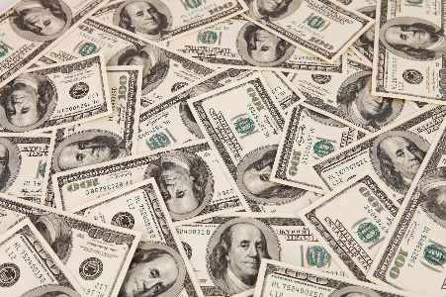
- _________________ is any kind of money that a creditor must by law accept in payment for debts.
- The Bankruptcy Power
- Article I, Section 8, Clause 4 gives Congress the power “[t]o establish…uniform Laws on the subject of Bankruptcies throughout the United States.”
- ________________ is the legal proceeding in which the bankrupt person’s assets are distributed among those to whom a debt is owed.
- Commerce Power
- The __________________—the power of Congress to regulate interstate and foreign trade—is granted in the Commerce Clause of the Constitution.
- The Constitution places four limits on Congress’s use of the commerce power:
  - Congress cannot tax exports.
  - Congress cannot favor the ports of one State over those of any other in the regulation of trade.
  - Congress cannot require that “Vessels bound to, or from, one State, be obliged to enter, clear or pay Duties in another.”
  - Congress could not interfere with the slave trade (through 1808).
- Foreign Policy Power
- Congress has the __________ power to act on matters affecting the ___________ of the nation.
- Congress’s war ________ are extensive and substantial, including: the power to raise and support armies, to provide and maintain a navy, and to organize, arm, and discipline the military.
- Congress also has the power to ___________ the use of American forces in combat in areas where a state of war does not exist (War Powers Resolution of 1973).
- Other Legislative Powers
- _________________ is the process by which citizens of one country become citizens of another.
- Article I, Section 8, Clause 7 says that Congress has the power “[t]o establish Post Offices and post Roads.”
- A ______________ is the exclusive right of an author to reproduce, publish, and sell his or her creative work.
- A ________ grants a person the sole right to manufacture, use, or sell “any new and useful art, machine, manufacture, or composition of matter.”
- Non legislative Powers
    - Constitutional Amendments
  - Article V gives Congress the power to propose amendments by a two-thirds vote in each house.
    - Electoral Duties
- In certain circumstances, the Constitution gives Congress special electoral duties.
- If no candidate for President receives a majority in the electoral college, the House decides the election.
- If no candidate for Vice President receives a majority in the electoral college, the Senate decides the election.
- Also, if the vice presidency is vacated, the President selects a _____________, who faces congressional approval by a majority vote in both houses.
- Non legislative Powers: Impeachment Power
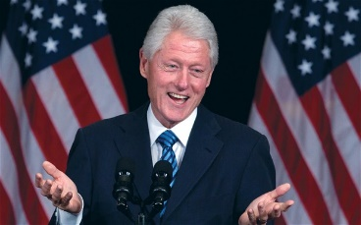
- The Constitution grants Congress the power of removing the President, Vice President, or other civil officers from their office through impeachment.
- The House has the sole power to ________, or bring charges against the individual.
- There is then a trial in the Senate. A two-thirds vote of the senator’s present is needed for conviction.
- The penalty for conviction is removal from office.

- Investigations and Oversight
- Investigatory Power
- Congress may choose to conduct investigations through its standing committees for several reasons:
  - to gather ______________ useful to Congress in the making of some legislation
  - to oversee the _____________ of various executive branch agencies
  - to focus ________ attention on a particular subject
  - to expose the questionable activities of public _________ or private persons
  - to ___________ the particular interests of some members of Congress.
- The Power of Oversight
      - Checks and Balances
- _____________ can check how the executive branch has administered the law and decide whether it met the law’s goal
- Even though they have broad ___________ they use them inconsistently
- Reasons why oversight fails:
- Not enough staff
- Oversight does not interest many voters, unless a scandal is uncovered or major problem
- Some regulations are so vague that it is difficult to know what they mean
- Committees sometimes come to favor the federal agencies they are supposed to oversee
      - How Congress Limits the Executive
- ____________________________
- All major appointments made by the President must be confirmed by the Senate by majority vote.
- Only 12 of 600 Cabinet appointments to date have been declined.
- “Senatorial courtesy” is the practice in which the Senate will turn down an appointment if it is opposed by a senator of the President’s party from the State involved.
- __________________
- The President makes treaties “by and with the Advice and Consent of the Senate,... provided two thirds of the Senators present concur.”
- Presently, the President often consults members of the Senate Foreign Relations Committee

- Congress and the President
- Sources of Tension
- Checks and Balances
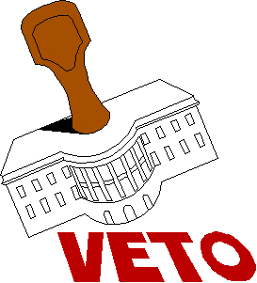
- Under the ________________, the President shares his most important duties with Congress
- All bill Congress passes require the _____________ cooperation
- The system of checks and balances gives Congress and the _______________ several tools to counteract each other
- Party Politics
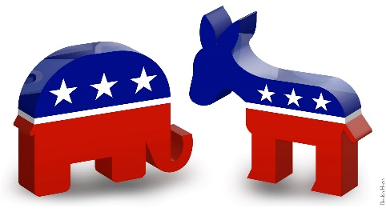
- Most elected officials are loyal to their ___________ party and philosophies
- Partisan politics can affect relations between the __________ and congress
- This issue is __________ if one party controls the White House and the other controls the House and Senate, this divides the government
- The Balance of Power
- Emergency Powers
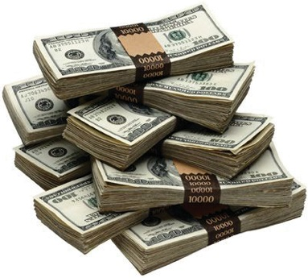
- In times of crisis Congress has given ______ power to the Presidents
- Presidents have declared martial law, seized property, and _______________ transportation and communications
- Balancing Budget Powers
- Presidents have assumed more ______________ for planning the national budget
- Congress merely reacts to budget ___________, but they increased their role to ensure that the President was spending the funds on ____________ they have approved
- Legislative and Line-Item Vetoes
- Congress wields legislative ______ to invalidate actions by the executive branch
- Budgets must go through ____________ giving them a veto ability on the budget
- ____________ veto is a power that many state governments have, but in the federal government vetoing only part of a bill
