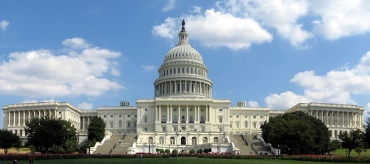
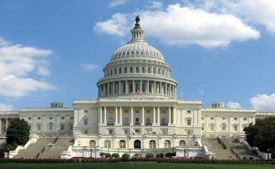
Legislative Branch
Chapter 5: Structure of Congress
- Congressional Membership
- Organization of Congress
- Bicameral Legislature
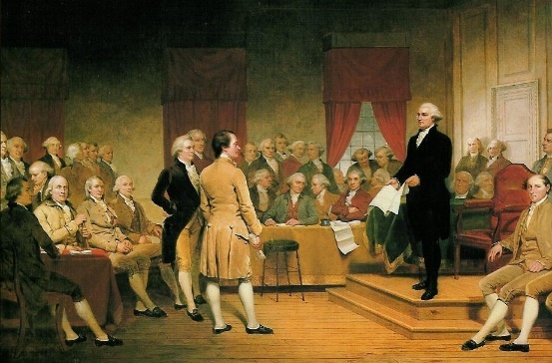
- Reasons behind two chamber legislature:
- _______________ The British Parliament consisted of two houses since the 1300s, and many colonial assemblies were similar in form.
- _____________ A bicameral legislature was necessary to compromise the Virginia and New Jersey plans of representation.
- ______________ The Framers favored a bicameral Congress in order that one house might act as a check on the other.
- It is quite ___________for the two champers to pass similar bills
- Before any _____ can be sent to the President, both chamber must agree on the which bill to send
- At their best they can ___________ compromise and national consensus, at their worst legislative gridlock or failure of ___________legislative work
- Terms
- A _______ is the length of time that officials serve after an election, as in a two- or six-year term.
- Senators enjoy six year terms
- Representatives enjoy two year terms
- The date for the start of each new term has been set by the ______________ Amendment (1933) as “noon of the 3d day of January” of every odd-numbered year.
- Congressional Sessions
- A __________ is the regular period of time during which Congress conducts business.
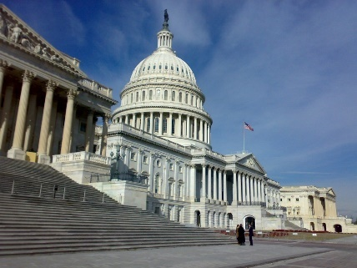
- Congress ______________, or suspends until the next session, each regular session as it sees fit.
- If necessary, the President has the power to ____________, or adjourn, a session, but only when the two houses cannot agree on a date for adjournment.
- Only the President may call Congress into a _______________—a meeting to deal with some emergency situation.
- Membership of the House
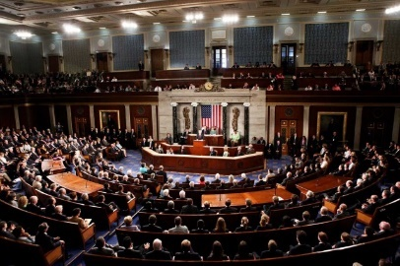
- Qualifications
- The Constitution says that a member of the House
  - ____________________________________
  - ________________________________________________
  - _______________________________________________.
b. The realities of politics also require some informal qualifications, such as party identification, name familiarity, gender, ethnic characteristics, and political experience.
- Terms
- Members are elected to the House of ___________________ for two-year terms
- Representatives begin their term January __ after the November election
- Sometimes if a representative _____ or ________ a special state election must be held to fill the vacancy
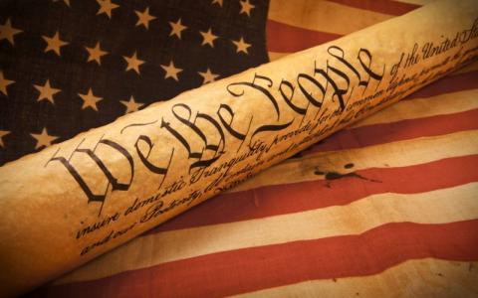
- Representation and Repatriation
- Article I of the Constitution directs Congress to _____________—redistribute—the seats in the House after each decennial census.
- As the United States grew in _____________, the number of ___________________ in the House also grew.
- The Reapportionment Act of ______ set the “permanent” size of the House at 435 members, and provided for “automatic reapportionment.”
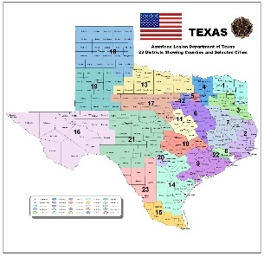
- Congressional Redistricting
- Each state every ____ years draws the boundaries for the congressional districts (one for each representative)
- Representatives are elected from these ___________
- Reynolds v Sims (1964) states that under the 14th amendment Both houses of bicameral _______ legislatures had to be apportioned on a population basis.
- Gerrymandering
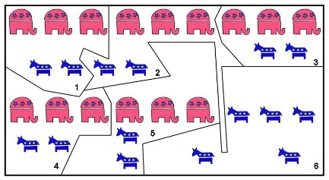
- Under the ________________________ arrangement, the voter’s in each district elect one of the State’s representatives.
- The general-ticket system, no longer in use, provided that all of a State’s seats were filled __________.
- Districts that have unusual shapes or even defy description have sometimes been _____________________.
- Gerrymandering refers to the act of drawing _________________ districts to the advantage of the political party that controls the State legislature.
- Membership of the Senate
- Qualifications
- The requirements for the U.S. Senate are higher than for the House of Representatives.
- The Constitution says that a Senator
  - _____________________________________________
  - ________________________________________________
  - ________________________________________________

- Terms
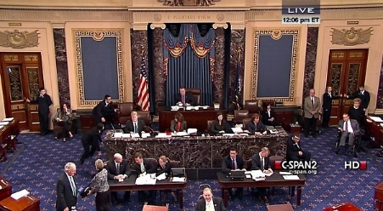
- The Constitution says that the Senate “shall be composed of two Senators from each State.” Today’s Senate consists of ___ Senators.
- Originally, the Constitution provided that senators were chosen by the _______ legislatures.
- In ______ the Seventeenth Amendment was passed and called for the popular election of senators.
- Senators serve for __________ terms.
- The Senate is a ________________, meaning that all of its seats are never up for election at the same time.

- The House
- Rules in the House
- Complex Rules
- Each chamber has scores of ____________ based on past rulings that serve as a guide for conducting business
- House rules are generally ________ at defining the actions an individual representative can take.
- Complex rules are geared toward moving ____________ quickly once it reaches the floor
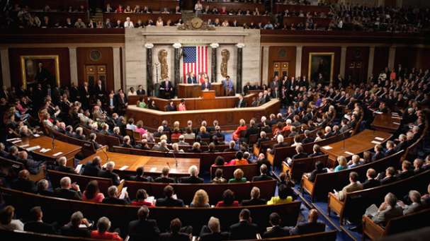
- Committee Work
- Because of its size _______________ work is more important in the House
- Committee work allows ________________ to have more influence on the House floor
- It also gives ______________ the time to study and shape bills
- Representatives serve on committees that are important to their ________________
- House Leadership
- Goals of the House Leadership
- Organizing and unifying party members
- Scheduling work
- Making certain that lawmakers are present for key floor votes
- Disturbing and collecting information
- Keeping the House in touch with the President
- Influencing lawmakers to support their party positions
- Speaker of the House
- The _________________________ is the presiding officer of the House of Representatives and the acknowledged leader of the majority party.
- The Speaker’s main duties revolve around ____________ over and keeping order in the House.
- The Speaker names the members of all select and ________________ committees, and signs all bills and resolutions passed by the _________.
- House Floor Leaders
- The _______________ are party officers picked for their posts by their party colleagues.
- The party ______ assist the floor leaders and serve as a liaison between the party’s leadership and its rank-and-file members.

- The Senate
- The Senate at Work
- The _________ is called a deliberative body because it deliberates (formally discusses), public policies
- Senators handle issues that are of specific interest to their ________________
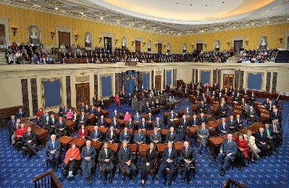
- They need to be very ___________________ about many issues from national defense to farming
- The chamber for the Senate only contains ____ desks
- The rules in the Senate are more flexible giving Senators _______________ freedom to express their ideas
- Leadership in the Senate
- The Vice President
- The job of _______________________ is assigned by the Constitution to the Vice President.
- The president of the Senate has many of the same duties as the _________ of the House, but cannot cast votes on ___________
- Majority and Minority Leaders
- The ______________________, the leader of the majority party, is elected from the Senate and serves in the Vice President’s absence.
- The _______________ is a closed meeting of the members of each party in each house which deals with matters of party organization

- Congressional Committees
- Purpose of Committees
- It allows members of ___________ to divide their work among many smaller groups
- From the huge number of bills that are introduced in ____________, committees select those few that are to receive further ___________
- Lastly, they are there to hold public hearing and ________________, committees help the public learn about key ___________ and issues facing the nation
- Kinds of Committees
- Standing Committees
- ________________________ are permanent panels in Congress to which bills of similar nature could be sent.
- Most of the standing committees handle _____ dealing with particular policy matters, such as veterans’ affairs or foreign relations.
- The ___________ party always holds a majority of the seats on each committee (the lone exception being the House Committee on Standards of Official Conduct).
- House Rules Committee
- The Rules Committee decides whether and _______ what conditions the full House will consider a measure.
- This places great power in the Rules Committee, as it can ______, delay, or even _________ House action on a measure.
- Select Committees
- ________________________ are panels established to handle a specific matter and usually exist for a limited time.
- Most select committees are formed to _______________ a current matter.
- Joint Conference
- A ____________________ is one composed of members of both houses.
- Examples of joint committees include the Joint Economic Committee, the Joint Committee on Printing, and the Joint Committee on the Library of Congress
- Conference Committees
- A ____________________________—a temporary, joint body—is created to iron out differences between bills passed by the House and Senate before they are sent to the President.
- Committee Chairman & Seniority Rule
- The _________________________ are the members who head the standing committees in each chamber of Congress.
- The chairman of each of these permanent committees is chosen from the __________ party by the ___________ party caucus.
- The _________________, an unwritten custom, holds that the most important posts will be held by those party members with the longest records of service in Congress.
- The head of each committee is often the longest-serving member of the _______________ from the majority party.

