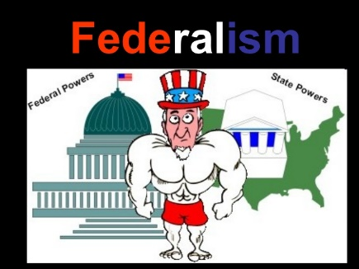
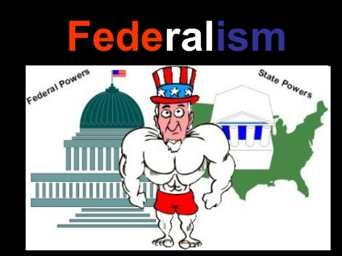
Foundations of Government
Chapter 4: Federalism

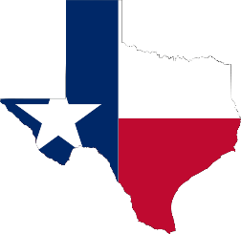
- Dividing and Sharing Power
- Why Federalism
- It was a new ________________ of governing the people
- __________________-two or more governments exercise power over the same people and the same territory
- In this system the federal government has some ___________ powers over all citizens
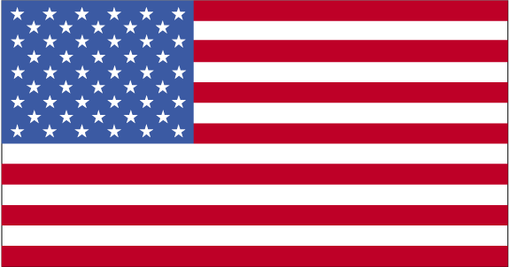
- The states have certain powers ______________ for them
- They are supposed to _________ some powers
- It can end with some ______________________ on the right formula for dividing and sharing power
- Federalism in the Constitution
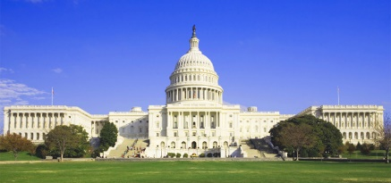
- National Powers
- The Constitution grants both ________________ and implied powers to the national government
- ________________ powers (enumerated powers) are those powers directly expressed or stated in the Constitution
- _______________ powers are those powers that are not stated specifically in the Constitution
- Concurrent Powers
- Shared powers between the _____________government and state government
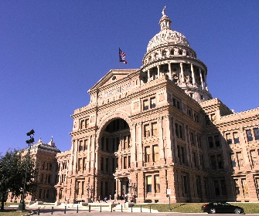
- Each level of government _______________ independently
- State actions must not ____________ with any national laws
- The Supremacy Clause
- Article _____ makes the acts and treaties of the United States supreme
- No _________ law or state constitution may conflict with any form of _______________law
- Local _____________________ cannot come into conflict with their own state ___________________ as well as the federal government

- Relations between the National and State governments
- Guarantees to and Obligations of the states
- Republican Form of Government and Protection
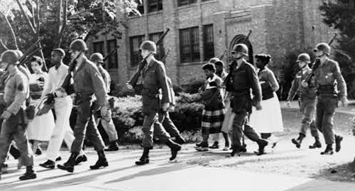
- The national government must guarantee each state a ____________________ form of government
- Voters must hold ___________________ power
- The national government must ___________ states from invasion and unrest within the United States, or attacks by ______________ power
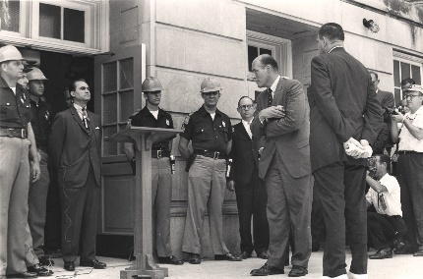
- Congress has given the __________________authority to send federal troops to a state where there is civil unrest and the __________________ or state legislature has requested help
- The president can send troops in to a state that ___________ federal laws
- The national government can also ___________________ in the aftermath of a natural disaster
- Territorial Integrity and Admission of New States
- Article _____, Section _____ says that the national government has the duty to respect the territorial ____________of each state
- The Constitution also gives Congress to pass laws that allow new __________ to join the nation
- Like all other laws, the _________________ of new states is subject to presidential veto
- Before a __________________ can become a state, Congress must pass an enabling act, so the ________________ can develop a constitution
- Once the constitution is approved by _______________ vote in the territory, Congress then votes on whether or not to accept the proposal
- Obligations of the States
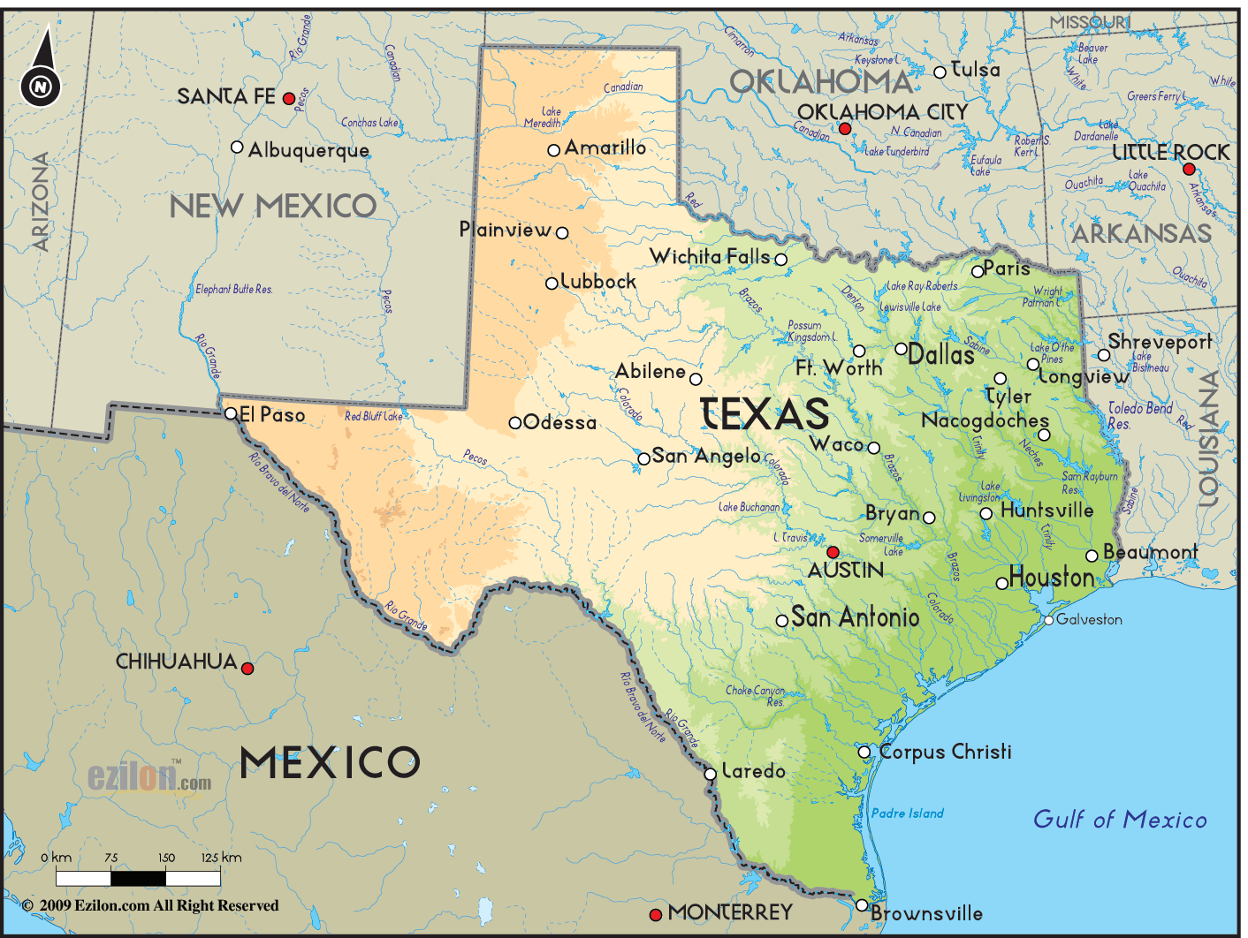
- Two functions states perform for the national government:
- ________ and _________ governments conduct and pay for elections of all national government officials
- States play a key role in the process of ______________ the Constitution

- Federal Aid and Mandates
- Federal Aid
- The ______________ government has always provided different types of aid to the states
- The main form of aid is through _____________ grants
- Sums of money given to state or local governments for specific purposes
- Mandates and Preemption
- _______________ Congress has taken over some functions that used to be controlled by the state governments
- A mandate is a law that _____________ states to take on an activity or provide a service that meets minimum national standards
- Congress may also pass a _______________ that limits a state’s ability to regulate an area
- Congress can pass laws that allow the ____________ government to assume _____________________ for a state government function (preemption)
- Conflicts
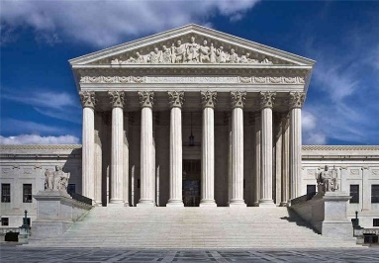
- _____________________ divides the powers of government, but conflicts do arise between the federal and state governments
- The federal court system, ___________________________, plays a key role to end these disputes
- McCulloch v. Maryland (1819)-concluded that when the ________________ government and a state government come into conflict, the national government is _________________
- Throughout the years, the Supreme Court has _______________ on this issue, sometimes siding with the national government other times the state.

- State Powers and Interstate Relations
- State Powers
- Regulating and Promoting Business
- States ________________ corporations within their borders and promote those businesses
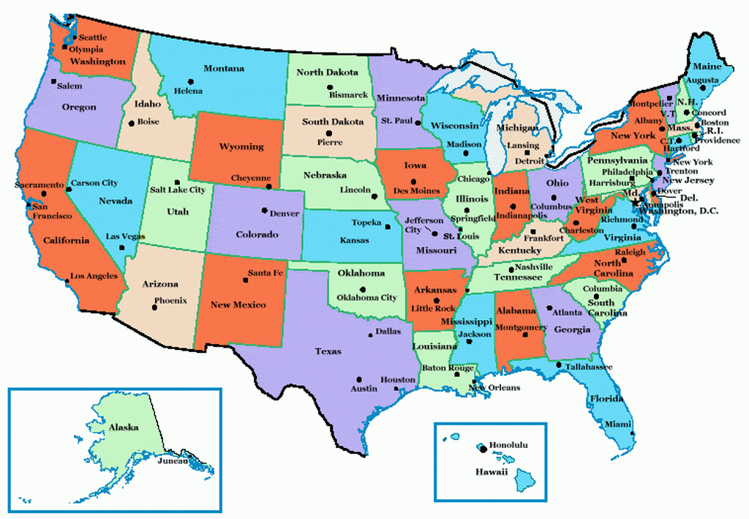
- The main goal is to help the state’s ______________ and provide ______________________ for state residents
- States regulate business to also protect the ________________
- States regulate business to protect the worker, to ensure ______ and _____________ working conditions
- States also might provide _________________ wage
- Crime
- Protecting ______ and ______________is the responsibility of state and local governments
- States call laws that _____________ citizens from certain crimes criminal codes
- Each state sets its own system of _______________________
- Local governments typically ______________ these state laws
- State courts handle the great majority of all _______________ cases
- Education, Health, and Welfare
- ___________________ is traditionally controlled by local governments, but the states finance about half of education, feds 10%
- Health care: states _____________ doctors and dentists, require ________________ for children, support ____________ hospitals
- Governments provide ________ to needy families with children, people with disabilities, and to people who cannot afford health care.
- Environment
- States try to preserve their _______________ resources by regulating air and water pollution
- Regulations impact the ___________ of residents and the economy of the states
- Relations Among States
- Privileges and Immunities
- The __________________ wanted to protect citizens as they traveled between the states
- The ________________________provides that “the Citizens of each State shall be entitled to all Privileges and Immunities of Citizens in the several States.”
- One state cannot _______________________ unreasonably against citizens of another state
- The courts have never given a _________________ listing of all possible “privileges and immunities.”
- Residency of a state depends on how a state defines ___________________
- States can treat ____________________ residents differently if distinction is reasonable (example: higher college tuition to state colleges)
- Interstate Compacts
- The ________________________requires the states to settle their differences with one another peacefully
- Principal way states settle ____________________ is by negotiating interstate compacts (written agreements between 2 or more states)
- Congress must approve ___________________ compacts, this prevents states from threating the Union by making alliances among themselves
- Once a compact has been signed and approved by _________________ it is binding and enforced by the _________________ Court
- Lawsuits Between States
- Sometimes states are unable to ____________ their disputes through negotiation or interstate compacts, they can sue each other
- Reasons to sue another state:
- Cases in the West often involve ___________ rights
- States fight over the sewage from one state _______________ the water of another
- States fight over _____________________ lines

- Differing Views about Federalism
- Federalism and Public Policy
- State and Local Policies
- ___________ and __________ governments can serve as proving grounds for the development and testing of new policies
- In many cases ___________________ get created because multiple states have laws already in place giving people that right (19th amendment, 18th amendment, 26th amendment)
- _______________ law is a provision in a law that sets an automatic end date for the law
- _______________ law which prohibits public officials from holding official meetings that are closed to the public
- Relations Among States
- National Policies
- __________ policy is created at the national level and states follow
- The national government may ____________ policies on states if it believed those states were infringing on group’s basic rights
- National Power and the Commerce Clause
- Supreme Court decisions have _______________the constitutional power of the national government to regulate interstate commerce
- The Court has interpreted the term ________________to mean almost any activity connected with producing, buying, selling, and transporting goods across state lines
- The Court has also issued few ruling that __________ the legislative powers that the commerce clause grants to the federal government
- Federalism and Political Parties
- Supporters of Stronger State and Local Government Powers
- 21st century _______________________ (Republican, Tea Party, libertarians)
- They believe that the _____ amendment sets clear limits on the power of the national government and states have more power
- They believe that the _______ and ________ governments are closer to the people and know how to best help them
- Tend to use the term _____________________________
- They are more likely to ____________ broad federal laws and regulations that limit states’ __________________ to legislate as they wish
- Supporters of Stronger National Government Powers
- 21st century _____________ (Democratic Party and Progressives)
- They believe that the _______________ confirmed that they tended to create a strong national government
- They use the ___________________ clause to argue that the national government should be supreme in matters of public policy
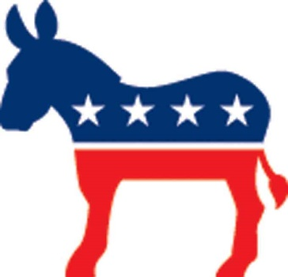
- They believe that under the _______________ clause the powers expressly delegated to the national government should be expanded
- They believe that the _______________ government is better equipped to solve some major social and economic problems
- Federalism and Political Participation
- ____________________ increases opportunities for American citizens to participate in politics
- American federalism gives citizens many points of access to government and increase their opportunities for __________________ public policy
- Citizens may also work with ________________ interest groups to influence national policies and state and local government agencies
- A related effect of federalism is an ________________ chance that one’s political participation will have some practical impact on policy

