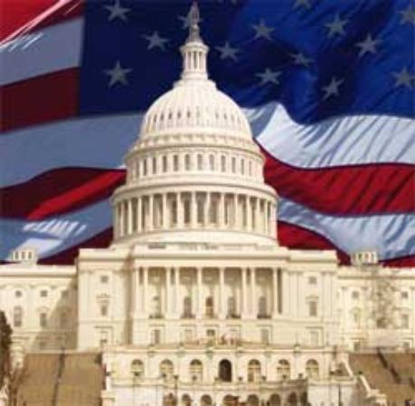
Foundations of Government
Chapter 3: The US Constitution

- Structure and Principles of the Constitution
- Structure of the U.S Constitution
- The new country was a combination of their experiences under the ______________ and as a _____________ colony
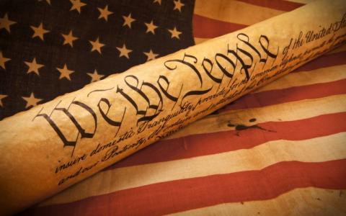
- The Founders solution to all the problems they experienced was a central government with ____________powers
- They divided power between ________ branches with a system to ___________ the other two branches
- Power was divided between the __________and federal government
- The Constitution presents the government’s _______________, principles, ______________, and limitations
- ___________________________
- Explains why the Constitution was written and spells out the purposes of the government
- ___________________________
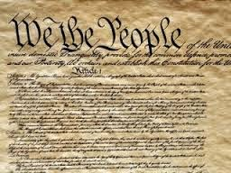
- Each article covers a different topic about how the government is structured
- Articles 1-3 create the three branches
- Article 4 explains the relationship of the states to one another and to the national government
- Article 5 explains the ways that Constitution can be amended
- Article 6 established the Constitution as the “supreme Law of the Land”
- Article 7 addresses ratification
- ______________________________________
- 27 amendments
- Some amendments describe people’s individual rights
- Most are modifications to the structure of government
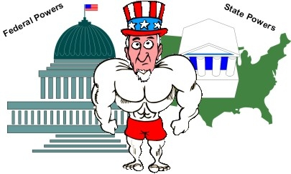
- Principles of The Constitution
- _________________________________ – powers are limited by the Constitution. King John signed Magna Carta in 1215 limiting the powers of the ruler.
- _______________________________ – the people hold the power and give the government its power. We consent to be governed.
- ____________________– power is divided between the national government and the states. Some are shared, some only for national government, some only for the states.
- ______________________________ – federal government is divided into three separate branches.
- ______________________________ – prevents any one branch from becoming too powerful, each branch can stop or ‘check’ the other two.
- ________________________– the people elect representatives to rule on their behalf

- Three Branches of Government
- The National Government
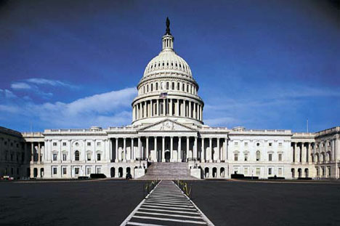
- The Constitution ______________ powers between the states and the national government
- It created __________ branches of government each having its own power
- The structure of this systems was to ensure that not one __________ or ___________ could have all the power
- To ensure the principle of ______________ government the Founders assigned different powers to the three branches and gave each branch a way to __________ the power of the other
- Legislative Branch
- Role is to make the ________
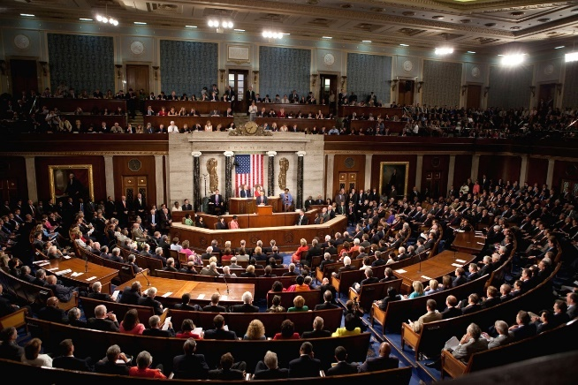
- It is divided up into ______ houses
- House of Representatives
- Senate

- The House of Representatives is determined by state _________________________
- The Senate each state can only send _________
- Enumerated and Express Powers
- The powers of Congress are listed under ______________, Section 8 in the Constitution
- Enumerated powers are listed powers that Congress have, such as:
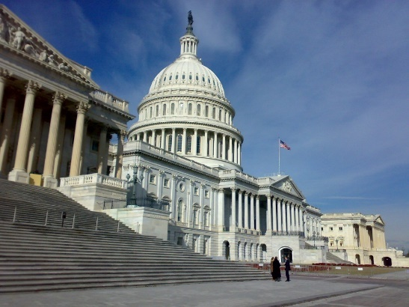
- Power to ________ taxes
- Borrow _____________
- _________money
- Punish _________________________
- ____________________ commerce
- Make laws for national defense (example: declare war)
- They can also naturalize citizens
- Establish post offices & courts
- Executive Branch
- The President is the head of the __________________ branch
- The executive branches job is to ______________ the laws passed by Congress
- There are ______ departments that are part of the executive branch
- The executive branch includes numerous _________________ agencies, boards, commissions, government corporations, and advisory
- Specific powers of the President (Article II, Sections 2 & 3):
- Grant _______________
- Make treaties
- Appoint ambassadors & ___________________ Court justices
- Fire officials in the executive branch
- Make ___________________ with foreign nations
- Take emergency actions to save the nation
- Commander of all __________________ forces but can only ask congress for a declaration of war
- Judicial Branch
- ________________________ establishes the federal court system (Supreme Court)
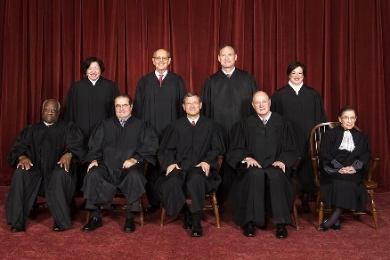
- Judges hold office for _________ unless they commit a crime or choose to retire
- Federal courts hear cases about the US _____________________, federal law, ________________ treaties, international law, and ________________________
- We have a ___________ court system, each court has the authority to hear certain kinds of cases
- Judicial Review
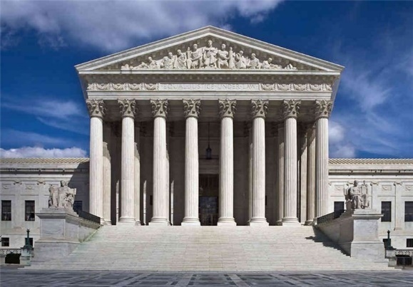
- Allows the courts to _______________ the Constitution and ________________ laws that violate the Constitution
- This is not specifically mentioned in the ______________________
- ____________________ Papers No. 78 discusses the power of judicial review
- Marbury v. Madison (1803) stated that _______________________ Act of 1789 which gave the Court more power than the Constitution allowed was __________________________
- Marbury v. Madison established _______________ review
- Relations Among the Branches
- Sharing Power
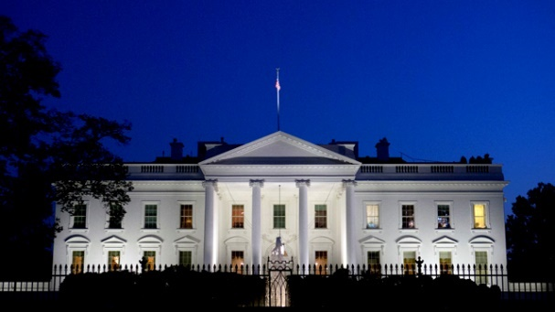
- To ensure a ___________________ doesn’t get too powerful they have to share many responsibilities with ____________________
- Example: President has the power to negotiate treaties with foreign countries but the Senate must approve them before becoming law
- Congress is limited by the need for Presidential ___________________
- Example: Congress passes but laws must be signed by the President. The President can veto bills but Congress with two-third vote can override it.
- Checks and Balances
- The ability to limit the other branches has caused a certain amount of conflict:
- Congress’s power to monitor how the __________________branch enforces laws
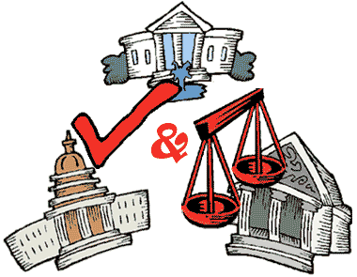
- Presidents have sometimes charged __________________with trying to encroach upon the proper powers of the executive to lead and ___________________the nation
- Sometimes the executive branch and legislative branch come into conflict with the _______________ branch
- In some rare cases a _____________________ has refused to enforce a Supreme Court _______________

- Amendments
- Proposing and Ratifying Amendments
- ________ methods of proposing amendments
- Two-Thirds vote in the House and Senate (all amendments were proposed by this method)
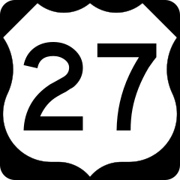
- Two-Thirds of the states ask Congress to call a convention to debate and then vote on the proposed amendment
- Once an amendment is ______________ Congress must choose how to obtain state approval:
- Legislatures in three-fourths of the states can ratify the amendment
- State holds special conventions and then to have three-fourths of the convention approve it
- ____________ amendments have been proposed over time, but only _____ have been ratified
- ________________ wanted to make sure that the procedure was difficult because they believed most issues could be handled with the _____________ political process.
- The Bill of Rights
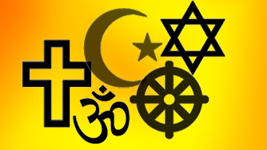
- 1st Amendment
- ________________________________
- _________________________________
- ____________________________________
- _____________________________________-.
- ______________________________________
- __________________________________________-
  - Right to Bear Arms
- ________________________________________
  - Prohibits Quartering of Soldiers
- ____________________________________________
  - No Unreasonable Searches
- 5th Amendment
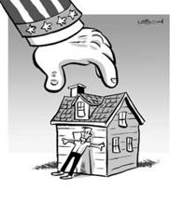
  - A person cannot be deprived of life, liberty, or property without _____________________________________. Certain legal procedures must be carried out before a person can be punished
  - Also contains:
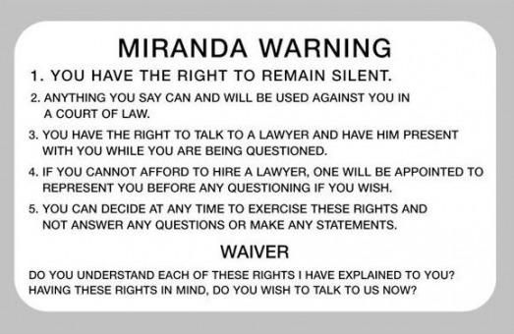
- _____________________________ gives government the right to take private property for public use, but they must give you fair compensation (payment) for the property. Like taking your home to build a road.
- _____________________________ cannot be tried for the same crime twice. Like OJ Simpson.
- ____________________________ is required to issue an indictment before you can be tried for a serious crime.
- ____________________________ cannot be forced to testify against yourself. Supreme Court ruling of Miranda v. Arizona says you must be informed of your rights or what you say cannot be used.
- ___________________________________
  - Fair and Impartial Trial
- ___________________________________
- Right to jury trial in federal courts to settle all disputes about property worth more than $20
- __________________________________________
  - No Cruel or Unusual Punishment
  - No high bail
- _________________________________________
- Just because the Constitution doesn’t list a right doesn’t mean we don’t have it. the people have all rights not specifically given to the government.
- _____________________________________
  - The federal government has only those powers specifically given to it in the Constitution. All other powers are reserved for the states or the people!
- Later Amendments
- ___________________________________________
- Prohibits a state from being sued in federal court by citizens of another state or another nation
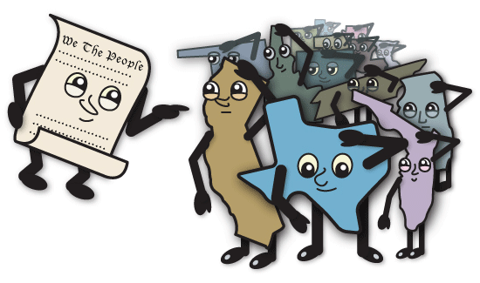
- __________________________________________
  - Calls for the Electoral College to use separate ballots in voting for president and vice president
- _________________________________________
  - Banned slavery in the United States
- ________________________________________
  - Granted citizenship to former slaves
- ________________________________________
  - Voting rights for former slaves
- ________________________________________
  - Established the federal government to tax a person income
- ________________________________________
  - Direct election of US senators
- ________________________________________
  - Made the manufacturing, transportation, or sell of alcohol illegal (Prohibition, repealed by the 21st Amendment)
- _______________________________________
  - Gave women the right to vote in the US
- _______________________________________
  - Set new dates for when the President and vice president are inaugurated and when congress can begin its term
- ______________________________________
  - Limits the President term in office to two elected terms
- _____________________________________
  - Granted voters in Washington, D.C. the right to vote for president and vice president
- _____________________________________
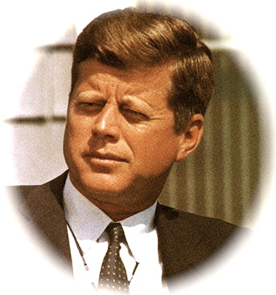
  - Forbade requiring the payment of a poll tax to vote in a federal election
- ____________________________________
  - Provided for succession to the office of president in the event of death or incapacity and for filling vacancies in the office of vice president
- ____________________________________
  - Lowered the voting age from 21 to 18
- ____________________________________
  - Banned Congress from increasing its members’ salaries until after the next election

- State Constitutions and Local Charters
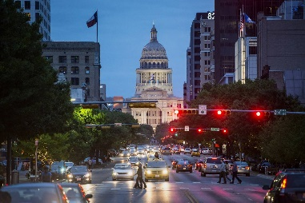
    - The Structures of State Governments
- Legislative Branch
- Pass laws that deal with a variety of ________________
- State legislatures have _________ power than US Congress
- Each legislature have ________________ Nebraska only has one chamber
- The Executive Branch
- Called the _____________________
- Power to ___________ out state laws
- Responsibilities
- Sign legislation
- Budgeting
- Appointing officials
- Planning economic growth
- Coordinate the work of executive departments
- Amount of control over the ___________________ branch varies between the states
- In some states the people vote for all ________________ of the executive branch
- Governors must work close with the _______________ government especially when it comes to federal funding
- They are commander and chief of the _____________ guard
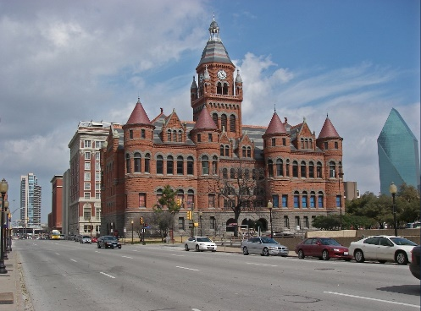
- The Judicial Branch
- They uphold and _______________state laws
- Help to resolve _____________ with citizens or business _________________________
- Courts can _______________ criminals
- Level of courts:
- Minor Courts
- Trial Courts
- Appellate Courts
- Highest Court: Supreme Court
    - Rights and Amendments in State Constitutions
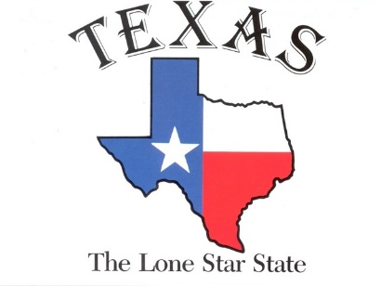
- All states contain a _______________________
- State Constitutions tend to have __________________number of amendment
- Average: 115
- Amendments might change the __________________ of the state government, redefine the powers allocated to the _________________ parts of government, or expand/restructure individual _____________
    - Local Governments
- Exist only if a state constitution ___________ them and gives them local ____________________
- Types of local government are based on their _______ and population
- State constitutions create _______, counties, townships, _____________________, special districts, ________________, and boroughs
- State constitutions can ____________________ the ways local governments can raise and spend money
- They are limited in their ______________ powers
    - Local Charters
- Documents that state ____________________ issues to local governments
- They grant communities a __________ status and allow them to have separate governments
- They explain the ______________ and responsibilities of the local government
- Explains how they __________ officials

