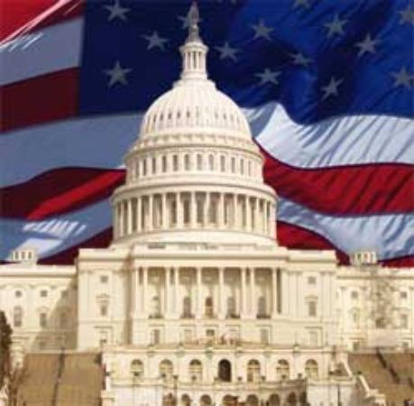
Foundations of Government
Chapter 2: Origins of American Government
- Government in Colonial Government
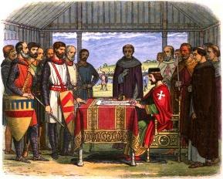
- Basic Concepts of Government
- The need for an ordered social system, or government.
- The idea of ________________________, that is, that government should not be all-powerful.
- The concept of _________________________—a government that serves the will of the people.
- Important English Documents
- The way our government works today can be traced to important documents in history:
  - Magna Carta-
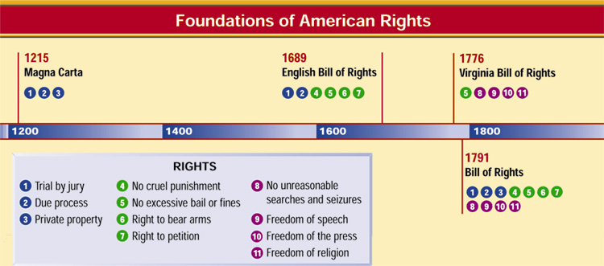
  - English Bill of Rights-

- Our Political Heritage
- Social Contract
- ____________________________ argued that people create a society by entering into a social contract
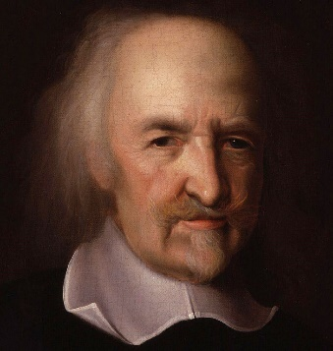
- He believed that people needed government to maintain __________
- People would give up their individual sovereignty in exchange for the government to provide _________ and ________
- Natural Rights
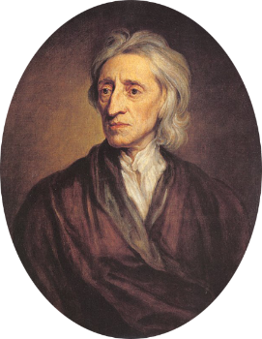
- ______________________ believed that people have “natural rights”, those rights people have simply because they are human beings
- Also called _______________________________ or the right to “life, liberty, and pursuit of happiness”
- Locke argued that the people had the right to _________ these rights and that people were justified to _______ and change the government to ____________ these rights
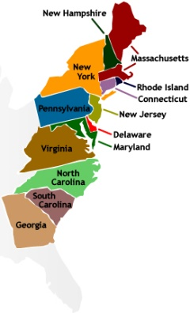
- The Thirteen Colonies
- There were three types of colonies in North America: royal, proprietary, and charter.
  - The royal colonies were ruled directly by the English _____________________.
  - The King granted land to people in North America, who then formed ________________________ colonies.
  - The charter colonies were mostly __________________, and their charters were granted to the colonists.
- Written Constitutions
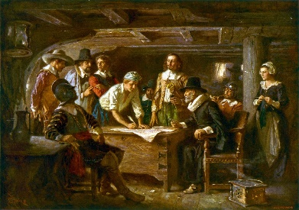
- Government according a _______________ plan was a key feature of the colonial period
- The Mayflower Compact signed in _______ by the Pilgrims was the first of many plans for self-government
- In ________, Connecticut created the first formal constitution, called a charter
- The ___________________________________________ gave the people the right to elect their own officials
- Colonial charters divided the power among the ________________, legislative assembly, and _________

- Uniting for Independence
- British Colonial Policies
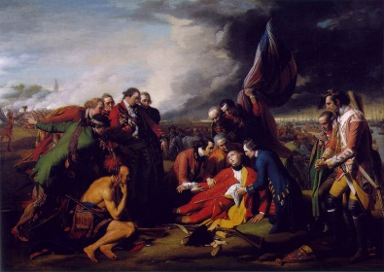
- Until the _____________, the colonies were allowed a great deal of freedom in their governments by the English monarchy.
- In __________________, Britain fought a war with France, the colonies had to be protected and it left Britain in debt
- In __________, King George III imposed new taxes and laws on the colonists.
- _______ on tea, sugar, glass, paper, and other products
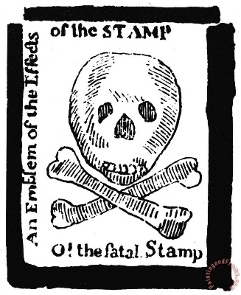
- Taxing the colonies
- _________, Stamp Act required them to pay tax on all legal documents
- British parliament even passed laws to ______________ trade so that Great Britain would benefit
- The colonist believed that the British could not tax them without ________________________ in parliament (“No Taxation without Representation”)
- The colonist _____________ against all the taxes, for which Britain retaliated by placing more laws on the colonists
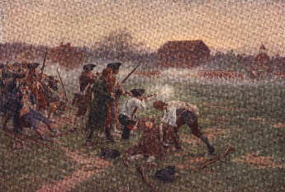
- Taking Action
- In _________, nine colonies sent delegates to protest their treatment, the result was a petition to the king
- By _________, the colonies were organizing to keep in touch with each other and to urge resistance to the British
- By __________, the British and colonist met in open fight at Lexington and Concord starting the American Revolution
- The Continental Congresses
- First Continental Congress
- The _______________ sent a Declaration of Rights to King George III.
- The delegates urged each of the colonies to refuse all trade with England until British tax and trade regulations were ______________, or recalled.
- Second Continental Congress
  - In ________, each of the 13 colonies sent representatives to this gathering in Philadelphia.
  - The Second Continental Congress served as the first __________________ of the United States from 1776 to 1781.
- Declaration of Independence
- Author: Thomas Jefferson
- Jefferson got many of the ideas for the document from _________________________, and other philosophers
- The Declaration explains the ______________ the colonies were angry with Britain and confirmed why the revolution was _______________.
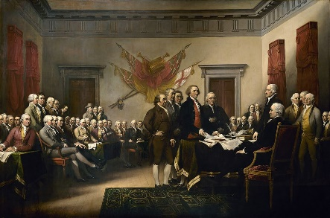
- Four parts of the Declaration
- ___________________: explains the basic rights of all men
- ______________ explains purpose of the document
- ______________ lists the grievances against the King
- _______________: explains the determination of the colonies to separate from Great Britain
- The Declaration does not create American ____________________but can be used a guide to understanding the Constitution.

- The Articles of Confederation
- The Articles of Confederation
- The Articles of Confederation established “a firm league of friendship” among the States.
- ______________________________
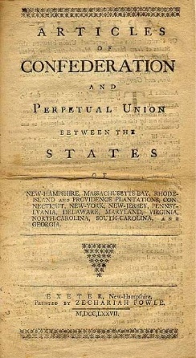
  - Congress was given the power to declare war, deal with national finance issues, and settle disputes among the States.
- ______________________________
  - The States promised to obey Congress, and to respect the laws of the other States. Most other powers were retained by each State.
- Government Under the Articles of Confederation
- Each state would retain significant ______________________ and there would be no strong central government
- Powers of the Central Government:
- No national _________ system
- No __________________ or king
- Legislature would only have ______ chamber
- Each state had one ________ in congress
- Problems with the Confederation
- Thirteen Sovereign States
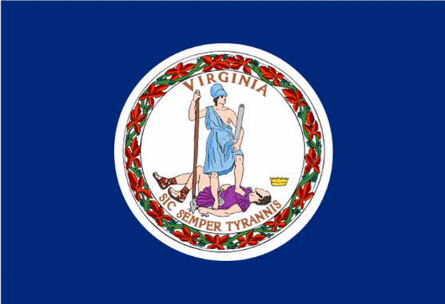
- People identified themselves by the state that they came from after the _____________________
- States had created their own __________________, which made _________ difficult among the states
- Some states charged rival states ____________
- States could also have _________ agreements with other nations
- The states could ignore the requests by ________________ to help __________ the national government
- A Weak National Government
- Congress could do little if a state refused its ______________to provide money
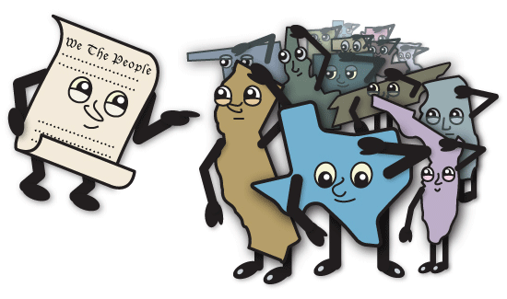
- No standing _________ and no power to regulate ________
- Congress passed very few laws because each _______ could become ______ only if delegates from nine of the thirteen states ________ for it
- Congress could not force anyone to _______ the laws they passed
- No national _________ system to interpret and _________ laws
- It became clear the ___________________ could not deal with the problems of the nations
- Achievements
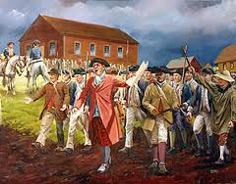
- In ________ the Confederation signed a peace treaty with Great Britain, which recognized Americas independence
- The Confederation developed _______ and _____________ policies for settling new lands west of the Appalachian Mountains (Land Ordinance of 1785)
- Congress set up the departments of ___________________, War, _____________, and the Treasury
- Even with the success it took a rebellion, ________________________________, to led to the Constitutional Convention

- Creating the Constitution
- The Constitutional Convention
- Key Agreements
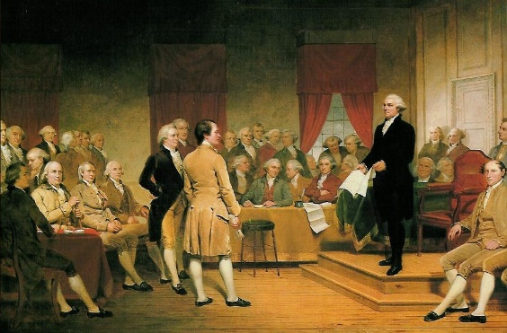
- The delegates all favored the ideas of _____________ & __________________________ government
- They all agreed that the ________________ government should be divided into __________ branches and power shared between each
- They agreed that the states should have _____________ power to coin money
- They also agreed that the _______________ government should have more power
- The problem was how to put these ideas into _________________
- Different Constitutional Plans
- The Virginia Plan
- ___________branches of government
- Bicameral legislature
- _____________________________ and “National Judiciary”
- The New Jersey Plan
- ___________________________Congress
- Equal representation for States of _______________ sizes
- More than one federal ____________________
- Constitutional Compromises (The Great Compromise)
- _____________________________________________________________
  - Delegates agreed on a bicameral Congress, one segment with equal representation for States, and the other with representation proportionate to the States’ populations.
- ___________________________________________________________________
  - The Framers decided to count a slave as three-fifths of a person when determining the population of a State.
- ____________________________________________________________________
  - Congress was forbidden from taxing exported goods, and was not allowed to act on the slave trade for 20 years.
- The Federalists and Anti-Federalists
- The Constitution was very controversial at first, with some groups supporting it, and others attacking it.
- ______________________________
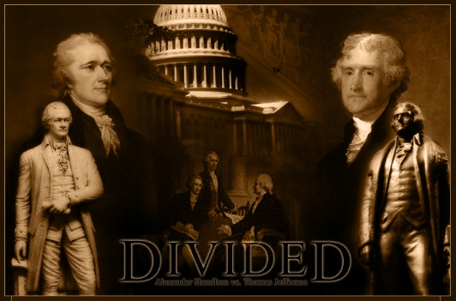
  - thought that the Articles of Confederation were weak, and argued for the ratification of the Constitution.
- ______________________________________
  - objected to the Constitution for many reasons, including the strong central government and the lack of a bill of rights
- The Constitution is Ratified
- _________ States ratified the Constitution by June 21, 1788, but the new government needed the ratification of the large States of New York and Virginia.
- ___________ debates were held in both States, with Virginia ratifying the Constitution June 25, 1788.
- New York’s ratification was hard fought. Supporters of the Constitution published a series of essays known as ________________________________________.
- Ratification
- ________ the Constitution was ratified
- _______________________________ became the first President and John Adams the vice-president
- Congress approved 12 amendments and the states ratified 10 of them in _________, which became known as the Bill of Rights
