Executive Branch
Chapter 10: Choosing the President
- Qualifications and Leadership
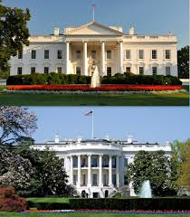
- Qualifications for the Presidency
- Constitutional Requirements
- Article II section 1 of the ________________ defines the formal requirements for the presidency.
- Must be a natural born citizen of the US
- Must be at least ____ years old
- Must be a resident of the US for at least 14 years before taking office
- The same requirements apply to the _______________________
- Informal Requirements
- To have a real chance at being elected _______________, the most important ___________________would be experience in government
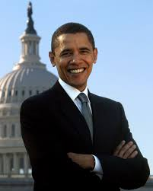
- Since _______, candidates who have served as US Senators or state governors have won their major parities presidential nomination
- Political Beliefs
- Extremely liberal or ________________ candidates have little chance of being elected
- Most candidates who are chosen by the major parties are __________
- Personal Characteristics
- _________________, most presents have come from northern European backgrounds
- Very few have been from ______ families
- Most of the ______________ have come from middle class families
- To date, every president has been a ______ and each has identified as _________________
- Financial Backing
- Running for the _______________ demands large amounts of money.
- ________________ pay for advertising, salaries of campaign staff and consultants, plus travel
- The Federal ____________ Commission tracks campaign spending based on reports required by the candidates
- Presidential candidates to amass the sums required usually have _________ financial support from many people
- Candidates who accept _________ financing for their campaigns are limited on how much they spend to the specific dollar
- Candidates who _________ public financing can spend as much as they can collect
- Leadership Skills
- Understanding the Public
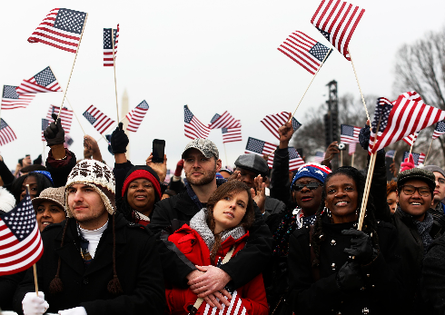
- A _______________ must know and understand the people
- Understanding the ___________ is necessary to gain and hold their support
- Public ___________, in turn, can give a president real leverage in influencing ________________
- When a ______________ is popular, presidential proposals and policies are better received by ___________, than when the ________ holds a president in low regard
- Failure to _______________ the public mood can prove disastrous for a president.
- Ability to Communicate
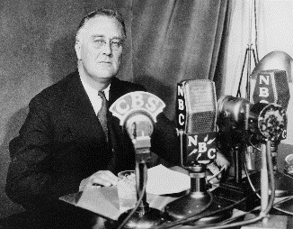
- Successful ________________ must be able to communicate effectively and to present their ideas in a way that inspires public support
- Modern presidents often use a ___________ of “going public” to appeal directly to voters
- Going Public-when the ______________ uses public opinion to persuade the Congress to follow his programs.
- Sense of Timing
- A ______________ president must know when the time is right to introduce a new policy, to make a key decision, or to delay such actions
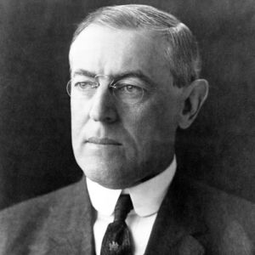
- Skillful presidents often use their ______________ or cabinet secretaries to test the timing of a new policy initiatives
- Public response to the issue may ______________ whether the president pursues, delays, or quietly drops a policy initiative
- Ability to Compromise
- Good ________________ requires the capacity to be flexible and open to new ideas
- Successful ______________ have to be able to compromise
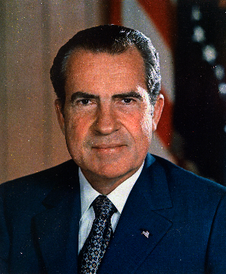
- Presidents who are ______________ leaders are able to recognize that they have to settle for legislation that provides only part of the programs they want
- Presidents who will not ________________ risk accomplishing nothing at all.
- Political courage
- Successful _______________ need political courage because sometimes they must go against public opinion to do what they think is best
- At times, presidents have shown _______________ and courage by going against traditional views of their own _______________ party.
- Presidential Salary, VP, & Succession
- Terms, Salary, and Benefits
- The __________________, originally, did not specify how many four-year terms a president could serve
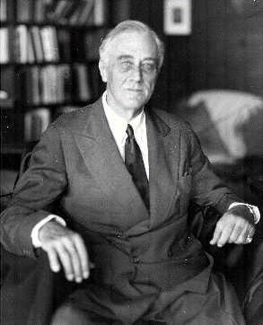
- After FDR and his ____ year term in office, and concerns over too much executive power the ____ Amendment was ratified (1951)
- 22nd Amendment-limits the terms of a president to ____ four-year, terms.
- Salary and Benefits
- The _________________ Convention determined that the presidents should receive compensation but left it up to congress to decide the amount
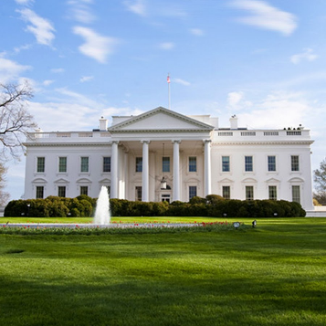
- Current ________________ salary: $400,000 per year
- Congress cannot ____________ or decrease the salary during a president’s term
- Other benefits are given to the _____________ for security reasons
- Salary and Benefits
- When a ___________________ retires, they will receive:
- 199,700 per year (same pay as cabinet secretaries)
- Free office space
- Free mailing services
- Lifetime Secret Service protection (for whole family)
- 96,000 per year to pay for their office help
- When the __________________ dies, their spouses are eligible for a pension of 20,000 per year
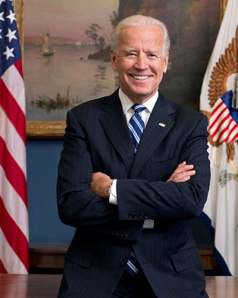
- The Vice President
- Constitutional Responsibilities
- Three duties of the VP:
- The Vice President takes over the ________________ in case of the presidential death, disability, impeachment, or resignation
- The Vice President presides over the _________ and votes in case of a tie (most VP’s don’t spend much time at this job)
- Under the _____ Amendment the Vice President helps decide whether the president is unable to carry out his or her duties and acts as president should that happen
- Modern Responsibilities
- The work and power of the VP can be much greater than the __________________ mentioned, it depends on the duties the president assigns to the VP
- In the beginning the VP was more of a ___________________ role
- Modern VP’s have had greater power from participating in ________ meetings to undertaking special assignments
- Qualifications when looking for a VP
- To add expertise to the future of the administration
- To appeal to the voters
- Succession
- _____ Amendment was created to clarify the succession to the presidency and the vice presidency
- The amendment first applied in ________, when Spiro Agnew resigned as Nixon’s VP and Gerald Ford was nominated as to succeed him
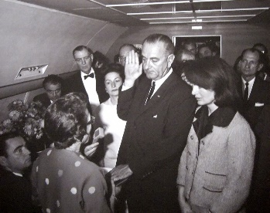
- The _____________ Act of 1947 established the order of the presidential succession if both the president and vice president both became ______________
- The order of succession:
- VP
- Speaker of the House
- President Pro tempore of the Senate
- Cabinet officers starting with secretary of state
- ____amendment describes what should be done when a president is disabled
- If the president informs Congress of an inability to perform in office
- If the VP and a majority of the cabinet or a body authorized by Congress inform the Congress of this conditions (only takes effect if the president is unwilling or unable to inform Congress)
- The 25th amendment also spells out how a ______________ can resume the powers and duties of the office.
- Electing the President
- Road to the White House
- Role of the Electoral College
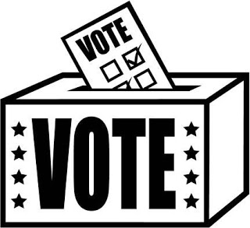
- The Constitution sets the basic rules for electing a president, including the role of the ______________College
- When drafting Article II, the ______________ argued about whether the president should be elected directly by the people, so they set up a system of ____________ for each state.
- Electoral College today:
    - Includes ______ electors (set up based on its senators and representatives)
- Texas has ____ electoral vote
- To be elected president or VP a candidate must win _____ of the _____ votes
- The candidate who receives the most ___________ votes in a given state wins all the electoral votes for that state
- Preparing to Run for President
- Years before a ______________ election, potential candidates being to plan their campaigns
- It starts by informing a political _______ committee, this organization of supporters test whether a candidate has enough national appeal to win
- ______ also begin raising large sums of money that would be needed for a campaign
- Candidates also form _____________ committees who meet with potential supporters and find well-respected public figures to endorse the candidate
- Candidates may also make their run official by _____________with the Federal Election Commission (FEC) an independent regulatory agency created by Congress to enforce federal election laws
- Primaries, Caucuses, and National Party Conventions
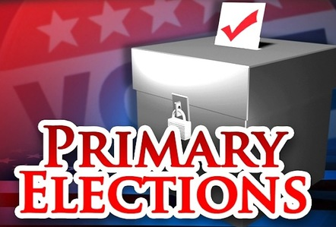
- First phase of the presidential campaign is to ____________ members of their own party to choose them over other candidates within their ________
- In a ____________ members of the party go to the polls to vote on which candidate they want to see earn their party’s nomination.
- Each state runs its own ___________ or caucus, and the dates and rules for these vary from state to state
- As they campaign for _____________ candidates will focus on issues that are important to the party’s active members
- ________________ will also focus on issues important to party voters in a particular region
- Late summer, when all states have held their primaries, the major political parties hold national _______________ conventions to determine who will actually run for president
- General Election
- Second phase in the ______________ process is to appeal to a wider circle of potential voters
- Campaigns will spend vast ____________ of money on commercials, and candidates will travel around the states they believe are most necessary to ______ the national election
- Campaign advisors study electoral maps to predicts which states electoral votes a candidate has a chance to win.
- Campaigning will often be concentrated in ______________ where polls show voters closely divided
- It is customary for _______________ candidates to debate one another in the run-up to an election
- On a presidential ___________ day, millions of Americans go to the polls and cast their votes for president and vice president
- The media reports on the results of the election as soon as the polls close in the evening and often project a winner by ______________
- Electoral College Issues
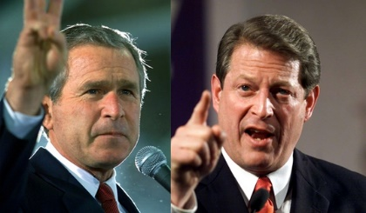
- Winner Takes All
- Some ______________ of the system believe that the electoral college system is unfair to those who voted for a losing candidate
- The winner-take-all system makes it possible for a _____________ who loses the popular vote to win the electoral vote
- This usually happens when a ________________ wins several large states by narrow margins
- Third-Party Candidates
- Third Party is someone who ______________ a political party that is not the democrats or republicans
- 3rd party candidates could win enough ____________ votes to prevents either major-party candidate from receiving a majority of the votes
- Third parties could then _____________ to release electoral votes to one of the two major-party candidates
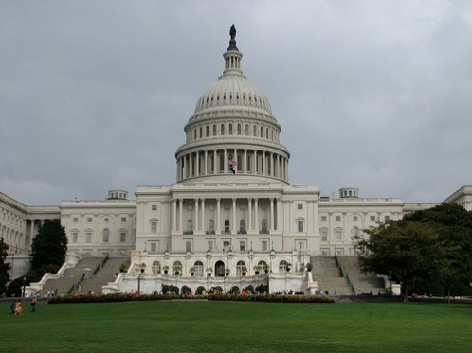
- Election by the House
- When neither presidential candidate wins ____ electoral votes, the House of Representatives must decide the winner
- Each state casts ____vote, the candidate who receives ___ or more votes is elected
- Election by House raises three issues:
- States with small populations have as much eight as populous states
- Under the rules if a majority of a state’s representatives cannot agree on a candidate the state loses its vote
- If some House members favor a strong third-party candidate it could be difficult for any candidate to get the 26 votes needed to win
- Ideas for Reform
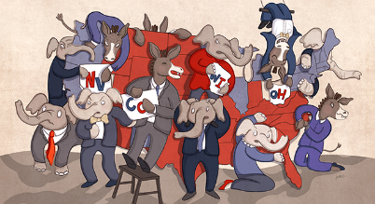
- One idea for reform is to choose _________ from congressional districts.
- Another idea is to assign _____________ votes based on the winner of the nationwide ____________vote (this method would not require amending the Constitution)
- Third proposed plan would allow the _______________ candidate to ____ the same share of a state’s electoral vote as they received of the _______ popular vote
- Other plans include the ______________ of the Electoral College, and allow the people to ____________ elect the president and VP
- The Inauguration
- Until the __________________ in late January, the new president is referred to as the president-elect
- The new president takes _________ at noon on January 20th in the year following the election
- The _________________ requires the president to take an oath.
- By custom, the incoming _______________ rides with the outgoing president from the White House to the Capitol for the inauguration when the chief justice administers the oath of office
- After the _______ of office, the president gives an inaugural address, several inaugural address have become part of the nation’s _______________.

