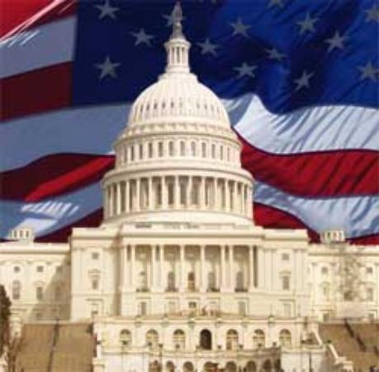
Foundations of American Government
Chapter 1: Foundations of Government
- Purposes and Origins of Government
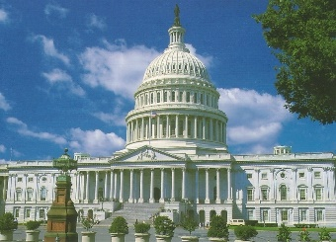
- The Functions of Government
- Legitimate governments create _________, protect people, and give people ways to settle _____________________________
- Governments provide ___________________, order, _______________, and defense
- To fulfill its purpose governments, make ___________ that everyone must follow
- Nation, State, and Country
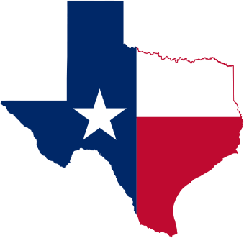
- These terms can sometimes be ________________________________
- A nation is considered a sizable group of people who believe themselves ________ by common bonds of race, language, custom, or religion
- In the United States a state is considered a _________________ of the whole country
- A state could also mean a ___________________ community that occupies a definite territory and has an organized government (same thing as a country)
Population  A state must have people, the number of which does not ________ relate to its existence. | Territory  A state must be comprised of ________—territory with known and recognized boundaries.
Sovereignty  Every state is ____________. It has supreme and absolute power within its own territory and decides its own foreign and domestic policies. | Government  Every state has a ___________— that is, it is politically organized.
- The State
  - The state can be defined as having these four characteristics:

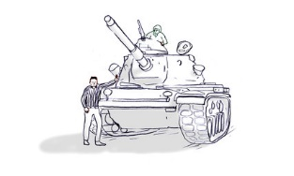
- Origins of the State
- _________________________________
- The force theory states that one person or a small group took control of an area and forced all within it to submit to that person’s or group’s rule.
- ________________________________________
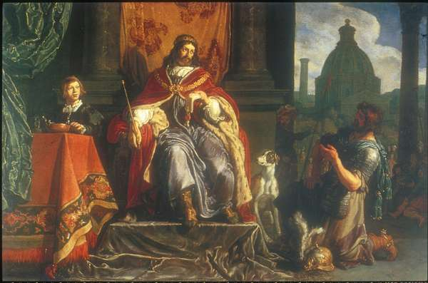
- The evolutionary theory argues that the state evolved naturally out of the early family.
- ________________________________________
- The theory of divine right holds that God created the state and that God gives those of royal birth a “divine right” to rule.
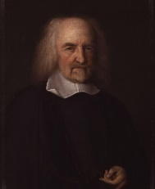
- ______________________________________________
- The social contract theory argues that the state arose out of a voluntary act of free people.

- Types of Government
- Classifying Governments
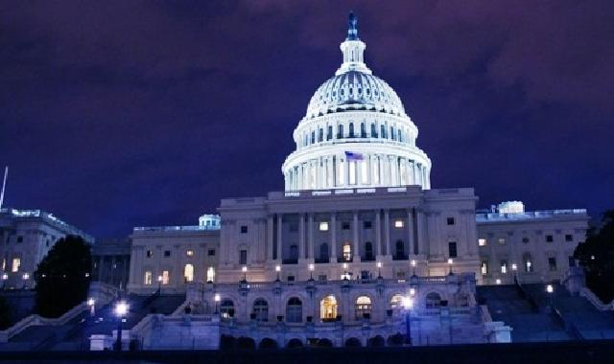
  - Governments can be classified by three different standards:
- Who can _______________________ in the governing process.
- The geographic ______________________ of the governmental power within the state.
- The relationship between the _______________________ (lawmaking) and the ______________________ (law-executing) branches of the government.
- Constitutional Governments
- A constitution is a plan that provides the __________ for government
- Major purposes of a constitution
  - It sets out ideals that the people __________ in and ______
  - It establishes the basic _______________ of government
  - It provides the ___________________ for the country
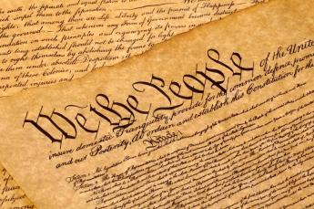
- Constitutions may be ___________ or _______________
- Constitutions have the ____________ to place clearly recognized limits on the powers of those who govern (______________________)
- They are _______________ guides on how the country should be run
- The constitution doesn’t always reflect actual _________________ practices
- Major types of Government Democracy
  - __________________________
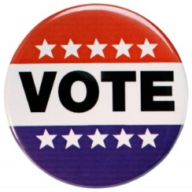
- In a democracy, supreme political authority rests with the people.
- A direct democracy exists where the will of the people is translated into law directly by the people themselves.
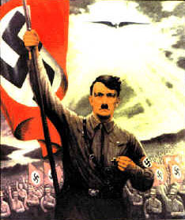
- In an indirect democracy, a small group of persons, chosen by the people to act as their representatives, expresses the popular will.
  - __________________________
- A dictatorship exists where those who rule cannot be held responsible to the will of the people.
- An __________________ is a government in which a single person holds unlimited political power.
- An __________________ is a government in which the power to rule is held by a small, usually self-appointed elite.
  - Unitary Government
- A __________________________________ has all powers held by a single, central agency.
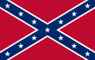
  - Confederate Government
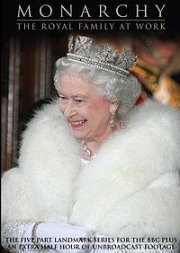
    - A _______________________ is an alliance of independent states.
  - Monarchy
  - Some are not ___________________________
  - Monarch’s power can be limited by ________________ or law
  - Most monarchies today are _____________________ monarchies (example: Great Britain)

- Roles of Government in Economic Systems
- Fundamentals of Economics
- Economics is the study of how people and nations use their __________ resources to attempt to ___________ wants and needs
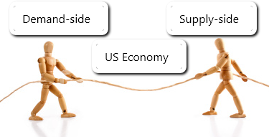
- Some political systems let ____________________ determine how resources are used
- Other systems the government _________________________ resources
- A key function of government is to make essential _____________ about the economy
- All economies must answer ____________ key questions:
  - What and how much should be produced?
  - How should goods and services be produced?
  - Who gets the goods and services that are produced?
- Capitalism
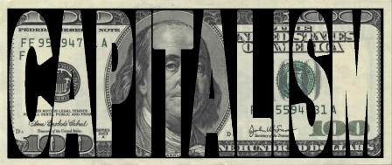
  - Is an economic system that emphasizes ___________ ownership of the factors of production, ______________ of choice, and individual _________________
  - The government does not _______________ with the economy
  - This economic system assumes that the best way to serve ___________ is to let people produce, sell, and buy as they _______
  - Free Enterprise in the United States
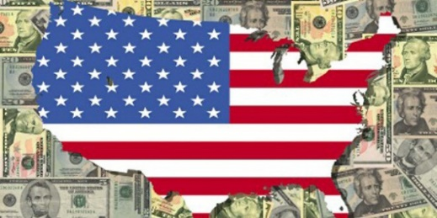
  - A true and total ___________________system does not exist in reality, but the US is the closest example
  - The US society is deeply rooted in the value of individual ______________________
  - The US respects the right of all persons _____________ private property
  - The US also recognizes the freedom to make _________________ choices
  - The US government does ________________ many aspects of the economy, which makes it not a pure ________________ system
- Mixed Economies
- Combine elements of _______________ and _______________
- Examples of countries with mixed economies: _______________
- Why is the US classified as a mixed economy?
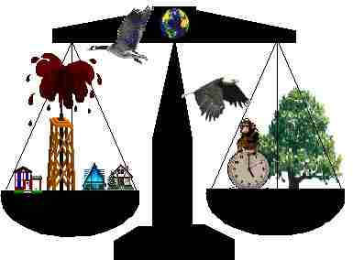
  - The federal government has grown to become the ________ largest buyer of goods and services
  - The federal government has become more involved in ___________ industries to _______ the consumer
  - The ________________ created an economic emergency that propelled ______________ action

- Socialism
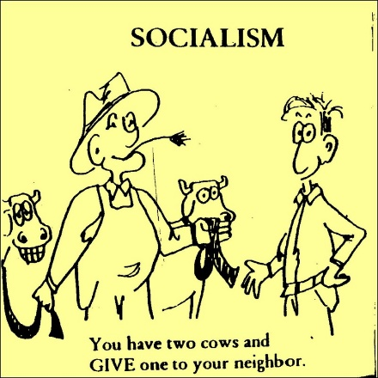
  - Is an economic system in which the government plays a ___________________ role in the economy, but does not ___________________ control it
  - It owns most land, basic __________________, and other means of __________________
  - Government planners determine the use of _________________ and distribute the products and wages
  - The government provides extensive ____________services such as education, health care, and welfare for its people
  - The goal is to _____________________ everything equally
- Communism
  - The government decides how much to ____________, and how to __________________ the goods and services produced
  - The state owns ________, natural resources, _____________, banks, and __________________________ facilities
  - There is ____ private property
  - Government controls _________________________________
  - All decisions on how the country should be done are handed down by the ___________ levels of government
  - Communism Today
  - Only a _______________ of countries that are communist exist (North Korea)
  - Most communist states ________ on how much of the economy is state controlled (China)
